Transition University of St Andrews
  - End of Year report 2018-19

  - diverse network of people with a common vision of a university and town that exemplifies the values and practices of sustainability
  - .

2018-19 End of Year Report

Executive Summary
Transition University of St Andrews was initiated by the One World Student group in 2009 as part of a national Transition Universities campaign. It rapidly grew support from staff and local residents as it sought to take local, practical action on climate change and build resilience to peak oil. Since then our relationship with the Transition Towns movement has strengthened across Scotland and the UK as we became a Transition Town member and build links to other groups through hosting networking events and organising training.
Within St Andrews University the role of Transition UStA has also expanded as the group seeks to work at all levels in support of the Universities world leading Carbon Neutral goals. Whilst the Transition UStA staff team have been based within the Estates department it has strong links to academic staff and takes an active role in supporting and influencing study so that it best serves a local transition agenda. This staff / student coalition appears to be a unique strength of the groups work and provides interesting benefits as well as challenges.
In recognition that for Transition to happen in St Andrews we must work across all sections of the community, the group has since 2012 taken active steps to ensure representation from our local community within our steering group too. The majority of our projects also have a town and gown focus which not only improves relationships between the two but also plays to the strengths of both. The University provide considerable support to the project in the form of staffing, accommodation, administration and access to vehicles and trades. This makes any funding go a long way and makes efficient use of resources.
Transition UStA’s development is marked by the considerable support of the Climate Challenge Fund which started in April 2011 and has seen 8 years of funding upto2020. Most of our work under the CCF has been in partnership with StAndEN and, more recently, the St Andrews Botanic Garden under the programme title “Community Share for Climate Care”
Although we are independent from University of St Andrews (as a constituted group & CIC), we receive considerable line management, IT, funding and systems support from them in recognition of projects we run. Projects independent of CCF include student waste recycling project, local food, conservation, and sustainability research and student energy reduction. We undertake a lot of work on sustainable travel including developing an electric car club (funded by EST), cycle routes development (SEStrans), travel behaviour change (funded by Smarter Choices via Fife Council), cycle parking development (Cycling Scotland)

Programme of Work

Climate Challenge Fund
There was a wide range of activities again supporting the communities shift to a lower carbon lifestyle by enabling people to learn, share, grow food, fix and mend together.
Food - Edible St Andrews: Develop a new “high quality” food growing demo space, in order to train growers from the wider community and increase yields across the 14 community growing spaces in St Andrews.
Travel - St Andrews Bike Initiative: Run bike maintenance workshops where community groups, schools and individuals can practice bike maintenance through “peer to peer” sessions. Continue to lead on developing cycle infrastructure across the town and developing training for led rides and bike ability.
Skillshare Extend the popular skillshare programme that provides practical help to tackle food waste and teaches preserving techniques by developing more sessions that enable participants to extend the life of tools, electronics, furniture, clothing, and energy savings devices (e.g. curtains, draught excluders).
Toolshare library: Set up tool loan scheme to reduce purchase of new tools and enable local residents to undertake repairs and enhancements at low cost.

Smarter Choices Smarter Places
This is the 4th year of working with Fife council on the Smarter Choices Smarter Places programme. that deliver works and activities linked to enabling and promoting smarter travel. The emphasis was on influencing 2200 University staff travel through scoping their travel use and developing a programme of targeted promotions and events to encourage less private car use. The main target group is the 500 staff moving to a new site who are concerned about travel and intending to drive more. This will be complimented by training and promotions of walking and cycling across the community and University under 3 themes:
- Safe and Secure Cycling,
- Low Carbon Commuting
- Promoting Smarter Travel

University of St Andrews
The University funds the Transition UStA manager post which has a remit covering project management, funding and staffing. It also funds a project worker post who’s role includes communications, St And Re-use and energy saving. The University, also provide crucial office space, line management, training and resources and additional project worker time that is currently focused on Edible Campus.

SESTrans
We have worked Sestrans and Bike Plus (COMO UK) to develop the Go E-Bike scheme in St Andrews that launched in June 2018. This saw the deployment of 12 E-bikes using a phone app based rental system. The bikes are initially available to university staff on a free loan basis in order to provide alternative to car travel within the town and between the new Eden Campus and town. An expansion of the scheme took place this year with more sites and more bikes.

Cycling Scotland
A successful application to Cycling Scotland led to us recruiting our second Campus Cycling Officer, employed through the Bright Green Futures internship programme. The Officer focused on how to develop a Cycle Friendly Campus at the new Eden Campus. The scheme aimed to
1. Give confidence to cycle
2. Ensure bikes are safe and kept secure.
3. Plan and initiate enhancement of cycle network relating to Eden Campus

Sustrans
Taking forward the development of the Crail to St Andrews Shared path is a long term vision for the communities along the route. This years programme looked to develop a feasibility study and negotiate with landowners about the route as well as engage locals in its development.
We also received funding for an arts project along the route from St Andrews to Eden Campus.

Headline Achievements
Table 1 CCF Carbon Emissions savings - Budget versus Actual
 | Project | BUDGET | ACTUAL
 |  | Project emissions saving /t CO2e | Project emissions saving /t CO2e
1 | Food - Edible St Andrews | 18.7 | 0.89
2 | Travel - Bike initiative | 18 | 26
3 | Sharing economy toolshare | 5.2 | 2.7
4 | Sharing economy - Skillshare | 0.3 | 0.6
5 | Sharing Economy- St And Re-use |  | 55.3
 | Total | 42.2 | 85.49

Calucluations for Carbon savings found using the Climate Challenge Fund Carbon Reporter Tool (except Bike initiative which uses assumptions shown in 5h)
Headline Achievements
- Increased harvest from Edible Campus to 1420kg including a record 295kg of hot house vegetables
- Logged over 2800 volunteer hours
- Fixed over 650 bikes
- Ran 129 Community Skillshares attended by 900 people
- Established a new Community Tool Share library
- Increased student re-use to the value of over £50000
- 68 volunteers 290
- Established a new shared E-Bike Loan Scheme

Income associated with Transition programme
The Transition programme is funded by a mix of direct grants, indirect spend from partners and costs paid through the University. We also received an important loan to enable cashflow for the Sustrans Shared Path Work.
Funding Source/ Project | Grant or Partners costs
Climate Challenge Fund (transition element of £150000) | 50,000
University | 72000
Smarter Choices Smarter Places (Fife Council) | 43096
Cycling Scotland (external) | 3,500
Sustrans - path feasibility | 39745
Sustrans - path engagement | 8530
Sustrans Art routes | 1200
Sestrans - Go E-Bike (external) | 56800
Total | 274,871
Foundation Scotland (Loan) | 9,717.51

This translates to an increase in the capacity of the Transition team and its contractors from 190 hours per week to 222 hours per week

Edible St Andrews

Introduction
The Edible St Andrews gardens aimed to increase its size and yield during this year as we increased our growing sites at the Low Carbon Community Hub – The Kernel. Reducing carbon emission through growing more food at more sites, introducing more community composting initiatives and training and offsetting the use of peat were aims of this years’ projects.
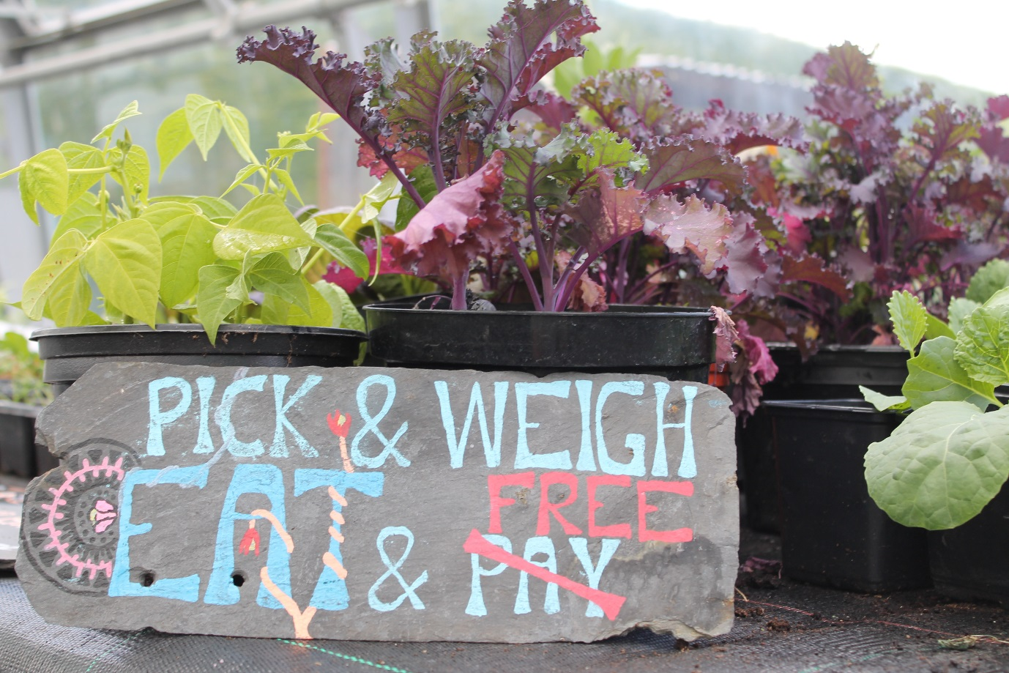
We continue to record the weight of all the food we harvest at all our sites. Looking back throughout year totals of food grown within Edible Campus is 1078.95kg. This is an increase as previous years include data from the Kernel.
YEAR | Kilos grown | t CO2 Saved
2012 | 25 | .04
2013 | 520 | 0.736
2014 | 612 | 0.945
2015 | 730 | 1.16
2016 | 1390 | 2.53
2017 | 1420 | 2.53
2018 | 1078.95 (Kernel Not included) | ….

Growing food | Period and date |  |  | Plot information
Plot identifier | Year number | Start date | Finish date | Growing area (m²) | Weight of useful produce in kg
Agnes Blackadder Hall | Y1 | 01/04/2018 | 31/03/2019 | 30 | 19.105
Albany Park | Y1 | 01/04/2018 | 31/03/2019 | 175 | 92.146
Careers | Y1 | 01/04/2018 | 31/03/2019 | 15 | 5.93
Community | Y1 | 01/04/2018 | 31/03/2019 | 120 | 151
Computing Science | Y1 | 01/04/2018 | 31/03/2019 | 20 | 3.035
Dean's Court | Y1 | 01/04/2018 | 31/03/2019 | 15 | 23.485
Gannochy | Y1 | 01/04/2018 | 31/03/2019 | 15 | 1.14
Greenhouse - Kernel | Y1 | 01/04/2018 | 31/03/2019 | 5 | 0.685
John Burnett Hall | Y1 | 01/04/2018 | 31/03/2019 | 30 | 8.2
Kernel | Y1 | 01/04/2018 | 31/03/2019 | 20 | 5.34
St Gregory's | Y1 | 01/04/2018 | 31/03/2019 | 3 | 2.18
St Mary's | Y1 | 01/04/2018 | 31/03/2019 | 63.5 | 105.27
St Regs | Y1 | 01/04/2018 | 31/03/2019 | 25 | 27.32
Uni Hall | Y1 | 01/04/2018 | 31/03/2019 | 29 | 15
English | Y1 | 01/04/2018 | 31/03/2019 | 8 | 3.91
Orchard | y1 | 01/04/2018 | 31/03/2019 | 400 | 615
TOTAL |  |  |  | 973.5 | 1078.947

Events:
We enjoyed, plenty of local events in St Andrews located at and around a number of our gardens. As our sites are set apart from each other, they have been a great way to get volunteers together as a community of food growers. The events such as tree pruning, garden tours and the harvest day were also very successful and promoting Edible Campus and Transition to the local community and encouraging more involvement in the project.
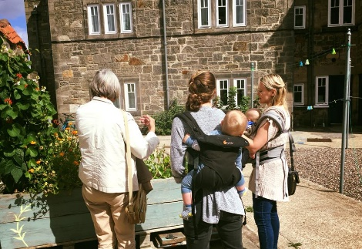
Edible Campus Garden Tours: Following on from previous years, we ran a monthly Wee Walks once a Week that was themed around the Edible Campus gardens and local food. We also Ran a few other session during events such as Car Free Day and from the local farmers market.

Apple Pressings and Harvest Day: We ran a few apple picking session at the community orchard, were folks were invited along an encouraged to take their own apples. Additionally we invited community members to the Kernel to press apples to take home as well as to bring their own apples for pressing. This event was very popular as it encouraged those who have a glut of apples to store it in the form of juice and share their abundance with those who don’t have apple trees.
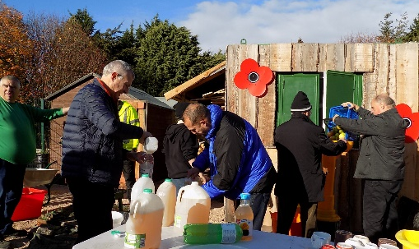

Tool maintenance: as a winter project we demonstrated how to sharpened secateurs and used the tool library at the Kernel to sharpen a number of our other tools
Soft Fruit Pruning: Led by horticultural expert Bob Bilson who demonstrated how to prune apples, gooseberries, raspberries, red and black currants. A practical session followed. The garden leaders then took their skills to their own edible campus garden – St Mary’s and the Community Garden to demonstrate how to prune soft fruit.
Winter Apple Tree Pruning: Out regular apple pruning session are paying off as the all apple trees in the community orchard are becoming more abundant, well maintained and looking healthy. We had a small group of 8 people, mainly locals attend this skillshare session.

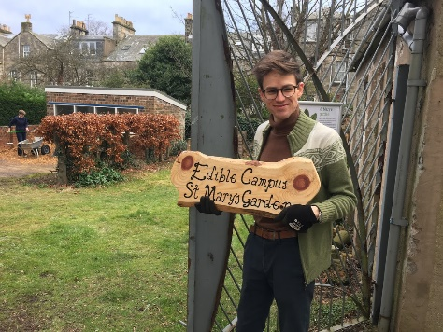
Sign making: using a router at the tool library and locally sources trees to upskill some of our garden leaders. The signs are being placed to direct more people to the sites as some of them are difficult to find.

Volunteers:
Edible Campus supports a large number of student volunteers and local residents. We ran 357 led sessions over the year. We encourage people to come visit the garden on their own to harvest; we had at least 107 visits of lone harvesters to the garden and possibly many more who did not record in the books.
“The quality of my work and relationships have been improved by gardening” Ben Norby, 4th Year Student
Edible Campus Gardens | No of sessions
Agnes Blackadder Hall | 42
Albany Park | 42
Careers | 10
Community Garden | 45
Computing Science | 12
Dean's Court | 12
English | 20
Gannochy | 12
John Burnett Hall | 21
St Gregory's | 12
St Mary's | 65
St Regs | 32
Uni Hall | 32
Orchard | 5
Total Led Sessions: | 362
Lone harvesters | 107

Volunteer feedback has been very positive. Students who originally come to the garden for a specific reason often find they learn new social and practical skills, become more environmental conscious and improve their overall wellbeing. As a result of getting involved with edible campus, those we surveyed the majority agree and strongly agree that they eat more local and begin behaviour changes.

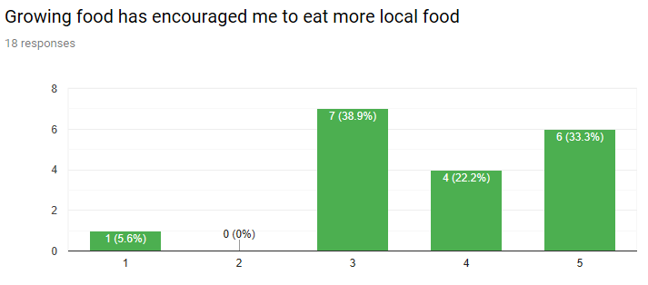
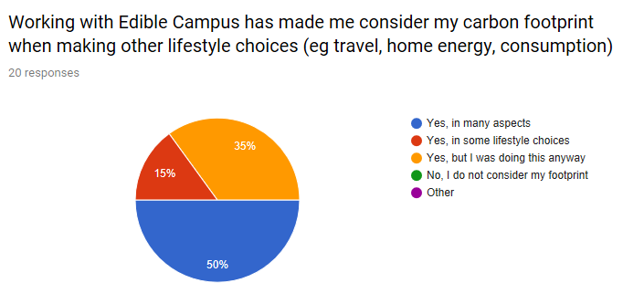

Supporting Garden Leaders:
The role of the garden leader has been developed this year by offering more support and practical guidance for planning their plots, leading sessions, seed sowing and following an overall schedule of jobs to do.
We recognise that their role holds tremendous value as they naturally develop a community within their hall and garden of volunteers who either come along regularly, or occasionally. Through promotions, events, word of mouth and social media a small community of food growers emerge as a sub community of the Edible Campus project as a whole.
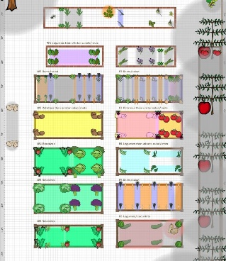
Planning the Plot: A focused demonstration on how to use our online plot planning tool. The garden leaders spent more time focusing on planning and thinking out the plots for optimum growing of food.
Monthly garden Jobs: Focused, detailed session were help monthly at the Kernel to go over specific jobs to do for the month in each garden. This was a discussion as answered specific questions and issues that arise. Practical demonstrations are offered if needed.
Grow at Home Course at the Kernel was designed to support gardeners in their home garden and was applicable to students running their own community garden. While some of the garden leaders were able to attend the course, unfortunately others had conflicting schedules or their roles were not in place in time for the course In future, this course would be better if it was ran in the spring, rather than from September to December.
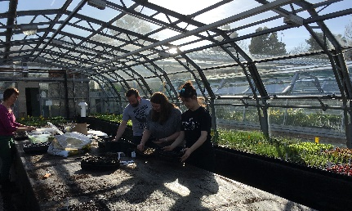
Masterclasses: are written and designed and will be rolled out in the summer and then again next year. This will offer an in-depth focus and various types of crops and is a follow on from the Grow at Home Course. Unfortunately the timing is such that most of our garden leaders are away for the first round.
Informal guidance is available at any time for garden leaders by lead horticulturalist and the Kernel and Edible campus worker.

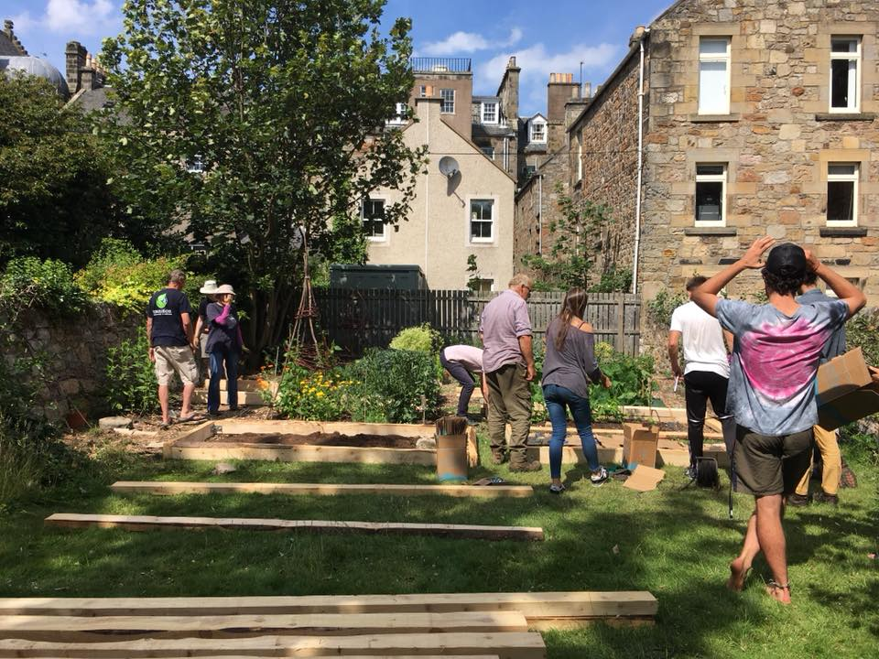
Edible Campus Sites:
We currently have two new growing spaces available to the project and both the new Halls that were developed this year. We were very pleased to see the University designing Edible gardening spots in their plans. They will be used during the current growing season
Additionally we have increased our growing space at a few of our sites for example St Mary’s now has 63m2 of food growing space and increase of 40m2. As an event we had a Raised bed Making Workshop (See photo) using wood from locally sources trees cut with some students using a Saw Mill machine at Pittarthie Farm.
The Kernel and Greenhouse:
The usable growing space at the Kernel has increased to its maximum of 1000m2 with a high intensity style Urban Farm. The polytonal, originally planned for the site is now located out with the Kernel as well as the demonstration plot visible to Botanic garden visitors increasing the growing space even further.

Discussion
Again, this year we grew more kilos of veg than previous years, 1078kg was grown at the Edible Campus sites.
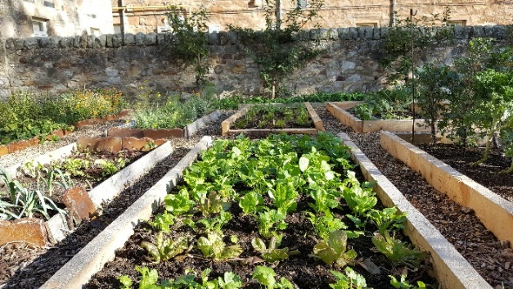
We have had a slicker more efficient seed sowing operation, producing more plug plants ready for planting. Although this operation is efficient in terms of producing a lot of seedlings, it has been less conducive to students and less mobile community members as there has been no communication on when the seed sowing will take place and therefore Edible Campus volunteers have not been able to get involved in this exciting part of the project.
With more efficient seed sowing, we received more plug plants to grow at each site for over wintering and for an earlier start to the growing season.
Going forward, Edible campus would like to have more ownership of their seed sowing as they do with their planting plans, growing and harvesting.
The support for garden leaders and interns are there, however we would like to see more uptake by students for the courses provided by the Horticultural team at the Kernel.
Our aim is to continue to educate people about food growing, provide a safe and relaxing growing space for people to use on their own, or in groups and work toward growing more food in more spaces in St Andrews.

Travel – Cycling

Introduction
Transition UStA works under the Universities Cycle Friendly Campus Strategy which has an action plan that includes physical/enabling works as well as behaviour change activity. The strategy and work undertaken enabled the University to achieve Cycle Friendly Campus with Distinction’ from Cycling Scotland in March 2017. Our work is steered through the Universities “ Bike User Group” where work on cycling is coordinated with partners and groups including the Environment Team, Security, Student services, local police, St Andrews Space for Cycling and the Students Association. The BUG was initially created to coordinate cycle safety campaigns but has expanded to look at all aspects of cycling.
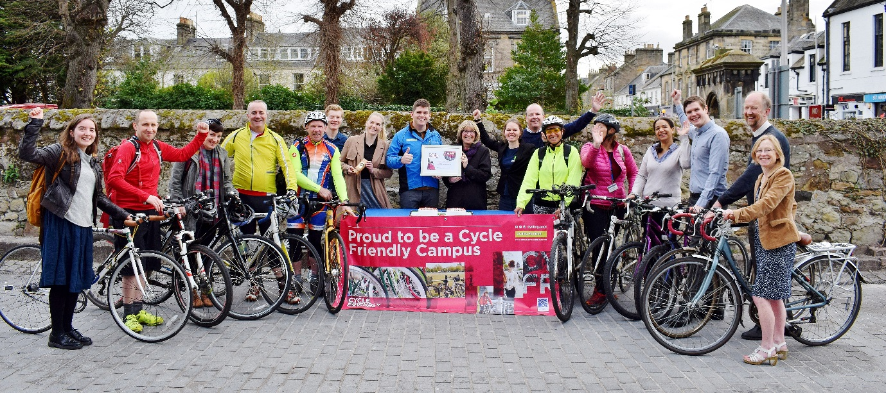

Outputs

Outputs – Activities planned to achieve outcomes | Actual outputs achieved
2 skill sharing bike maintenance sessions per week for 40 weeks, at a range of sites including Kernel, Community Centres, Students Association, University Departments and Halls, addressing attendee’s bike issues. | 53 Bike maintenance workshop undertaken at 5 different venues across the town fixing 383 bikes.
20 abandoned bikes will be refurbished during spring and summer at the University through weekly workshop sessions at our Bike Hub with volunteers. | Refurbished a further 13 bikes and added 10 brand new bikes to the fleet bringing it up to 134 bikes. Regular fleet maintenance sessions have provided practice for volunteer mechanics.
Bike loan scheme continued for University staff and students and community members. We switched over to using the MyTurn website to align loan with toolshare | Net Rental income was £2717
A summer scheme to loan bikes to groups for Conferences and Events will be established. | Another group of 25 Chinese students took a 2 week long loan of the bikes.
One community resident will work as an apprentice and be supported to gain Velotech Silver accreditation, embedding these skills more deeply within the community. | Achieved: 3 volunteers gained Velotech Silver accreditation.
Develop led bike tours around St Andrews by training volunteers to become ride leaders through Cycling Scotland. | 2 led rides undertaken.
1 Cycling Scotland Bike Leader Training or similar. | 6 People attended in March 2019
1 Cycle Scotland Cycle Trainer course | 6 People attended in March 2019
Bike Mechanic Basics Course | 4 courses attended by 12 people
GO E-Bike Induction (1hour essential cycling for adults) | 25 courses ran. 115 staff trained
Bike to work Breakfasts – These aim to bring commuter cyclist together and encourage take up | 10 bike to work breakfasts were held
Volunteers / Volunteer Hours | 410 / 1356hrs 56 hours
Attendees to Bike pool events | 3043

Training for Volunteers
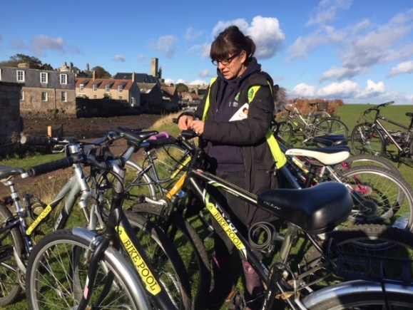
An essential part of developing the Cycle Friendly campus is to up-skill cyclists in bike maintenance and Cycling. We offer a one day basic Bike Maintenance training for our Bike Pool volunteers which is delivered by Cyclepath. Fifteen people took part this year and 4 of them went on to become regular volunteers with Bike Pool. We also offered three of them the 2 day Silver Velotech bike maintenance training undertaken at the Bike station in Edinburgh.
We are continuing to build a team of cycle trainers too in order to deliver Cycling Scotland courses such as Essential Cycling, Bikeabillity and led rides. We had 6 people undertake the Cycle Trainer course, which will allow us to undertake led rides for students unused to cycling in the UK and to do Bikeability courses in primary schools in St Andrews and beyond.
We also had eight people attend a Cycle Trainer Assistant one day course who aim to go into schools to assist with delivering Bikeabillity.

Bikeabillity in Schools
As part of the Smarter Choices Smarter Places programme we support Bikeabillity courses within local primary schools in order to increase uptake of cycling and make it more normal to cycle to school. With the training of volunteers coming late in the year we only had 1 trained member of staff able to deliver training. Courses were held at Anstruther Primary School (Level 1 and 2)and GreyFriars (Level 1) supported by bike maintenance delivered by our volunteers with Cyclepath.
In order to increase Bikeabillity courses being delivered we have created a local group of trainers that meets regularly and has its own facebook group to coordinate activity. Three further school sessions are planned at Lawhead, Greyfriars and Anstruther

Bike Lights Campaign
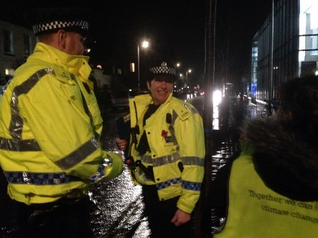
We again worked with student volunteers and Community Relations officer from the Student Association to run two events with community police officers. The plice were able to stop cyclists not using lights which allowed discussion and the give away of over 100 sets of lights. To highlight the different options for lighting up we created a “pimped-up” bike which our Sustainable Travel officer cycles around town in a bid to show students, in a fun way, that lighting up your bike is effective and that it is better to use more than just the compulsory two lights.
Surveys of bike light and hi-viz were undertaken in November and March to measure results. Unlike previous years, no change was detected in rates of use. However the second survey was undertaken in March when the nights were drawing out.

Cycling Safety Data Autumn 2018 compared to Winter 2019

Bike to Work Breakfasts
There were ten Bike to Work Breakfasts held between June 2018 to March 2019. A total of 110 journeys were made with registered journeys totalling 112 miles. The mix of people was slanted more towards university support staff with a very low number of locals attending (only five in total). The weather played an obvious part in the turn out with more than double the amount of people cycling into work in July than in January.

The Bike to work breakfasts are rewarding cyclists that undertake regular cycle’s to work with over 35 attendees saying they were undertaking around 150 to 200 journeys to work by bike each year.

Leuchars Bikeability Event
We supported the Fife Bikeabillity 2 day event in February held at Leuchars Army Station. There were seven stations at which, over the two days, 230 primary aged children learnt about safe distances to pass a car, explore blind spots in large vehicles, slow speed control on a bike, the benefits of a healthy active lifestyle and basic first aid. Transition asked students to investigate what factors make a cyclist stand out using dark glasses and a range of clothing, backgrounds, lights and reflectors. The students also had a fun time racing each other using our bike powered slot car racing.

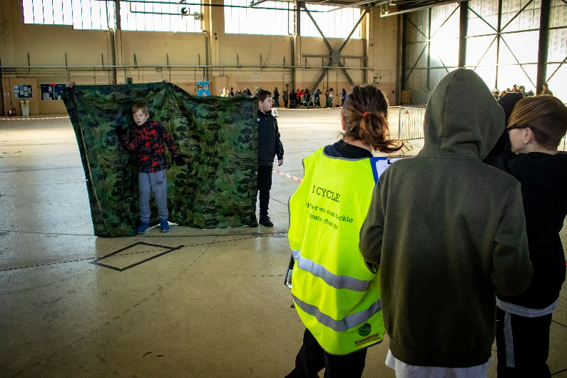
Figure 1 School children exploring factors that effect visibility on the road
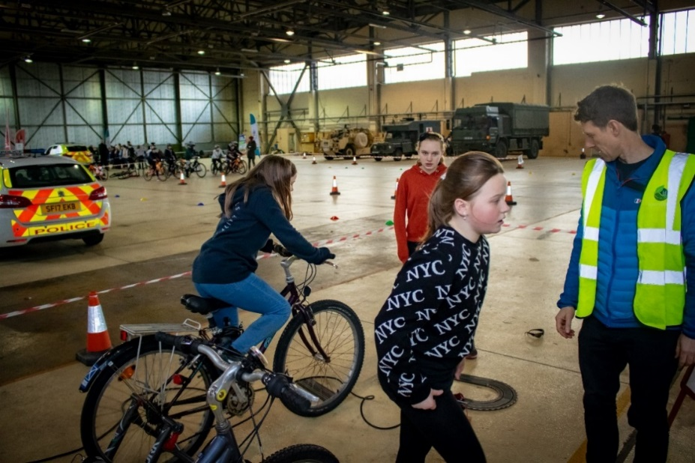
Figure 2 Schoolchildren racing slot cars using pedal power

Training for Bike Maintenance Volunteers
There has been a huge increase in the range and number of people being trained in cycle related skills this year as we aimed to increase the capacity of Bike Pool and deliver more practical cycling workshops.

We trained 12 people through four one-day Bike Mechanic Level 1 sessions. Again, there was a good mix of students and local residents taking part with many then going on to help out at bike pool sessions.

Cycle Training
Our programme continues to develop a team of local trainers in order to deliver basic Cycling Scotland Courses. We only managed to run one Cycle Trainer Course (Cycling Scotland) for 4 people this year and was unable to arrange school sessions within the year as Bikeabillity Level 2 but should be able to get them lined up for net year. We also ran 5 Essential Cycling Courses for adults in order to tackle one of the perceived barriers to cycling – confidence and ability.

Bike Pool Maintenance Sessions:
These have found to be crucial to reducing bike abandonments, improving safety and increasing cycling rates. We have delivered more sessions this year across more public sites whilst working with more volunteers. The number of bikes fixed has increased significantly as demand and our volunteer team grows.

 | 2014/15 | 2015/16 | 2016/17 | 2017/18 | 2018/19
Cycles Repaired | 275 | 643 | 735 | 559 | 643
Maintenance Sessions Run | 60 | 50 | 81 | 67 | 53
Volunteers Trained  Level 1 Bike Maintenance | 12 | 15 | 27 | 17 | 15
Volunteers trained to Cycle Trainer |  |  | 4 |  | 6
Volunteers trained to Cycle Trainer Assistant |  |  |  | 6 | 6

Outcomes
Our main aim is to increase cycling rates whilst displacing car journeys whilst also decreasing bike abandonments.
We have been tracking the quality of bikes found across the University in order to demonstrate how the bike maintenance scheme can improve bike quality and reduce abandonments. As seen in the table below there is a continuing trend towards improved bike quality.

Prior to Bike Pool being established around 150 bikes were found abandoned in St Andrews annually from 1290 bikes on campus (March 2016 count. Over 45% of bikes on campus (around 580 bikes) were either in poor or un-ridable condition. We assume that a Poor or Un-ridable bike has a 25% of being abandoned (150/580).
We found 25% of bikes were found to be in poor or un-ridable condition in February 2019 (equates to around 325 bikes on campus) leading to an estimated 81 bikes being abandoned this year. Bike pool is probably responsible for reducing the number from the previous 150 abandoned bikes saving 69 bikes this year.
This provides an estimated 26.4 tCO2e savings from the scheme
Bikes prevented from being Un-ridable | Average embedded emissions per bike / kgCO2e | Total CO2e saved/kg CO2e | Conversion to tCO2e
69 | 384 | 26,400 | 26

Second hand bike sales
During Orientation week we held two bike rental events and one cycle sale event where we collaborated with Bike Station Glenrothes and sold around 80 second hand bikes that had previously been abandoned at the University.

Go E-Bike shared bike scheme for staff

Introduction
The University of St Andrews has a strategic aim of relocating around 450 professional service staff to a new purpose-built campus in Guardbridge, which is 4 miles away from the town centre along a busy road. In order to give staff flexibility in their travel options and provide an alternative to car use an application was made to the Sestrans under their FAST 2017 grant scheme alongside a consortium of other further education and third sector organisations, towards the costs of a small shared E-Bike scheme (named GO E-Bike).
The GO E-Bike scheme uses a Phone App based interface to facilitate users accessing the bikes and managing maintenance. The main aims of the project for the University of St Andrews were to reduce private car use by:
- Providing an alternative travel mode for staff moving to the new the Eden Campus which is 4 miles from the centre of town.
- Creating a new transport link between the Town and Leuchars train station for staff
- Providing staff with a fast and efficient method of moving around town without vehicles
- Promote Cycling and E-Bikes as a way of commuting to work

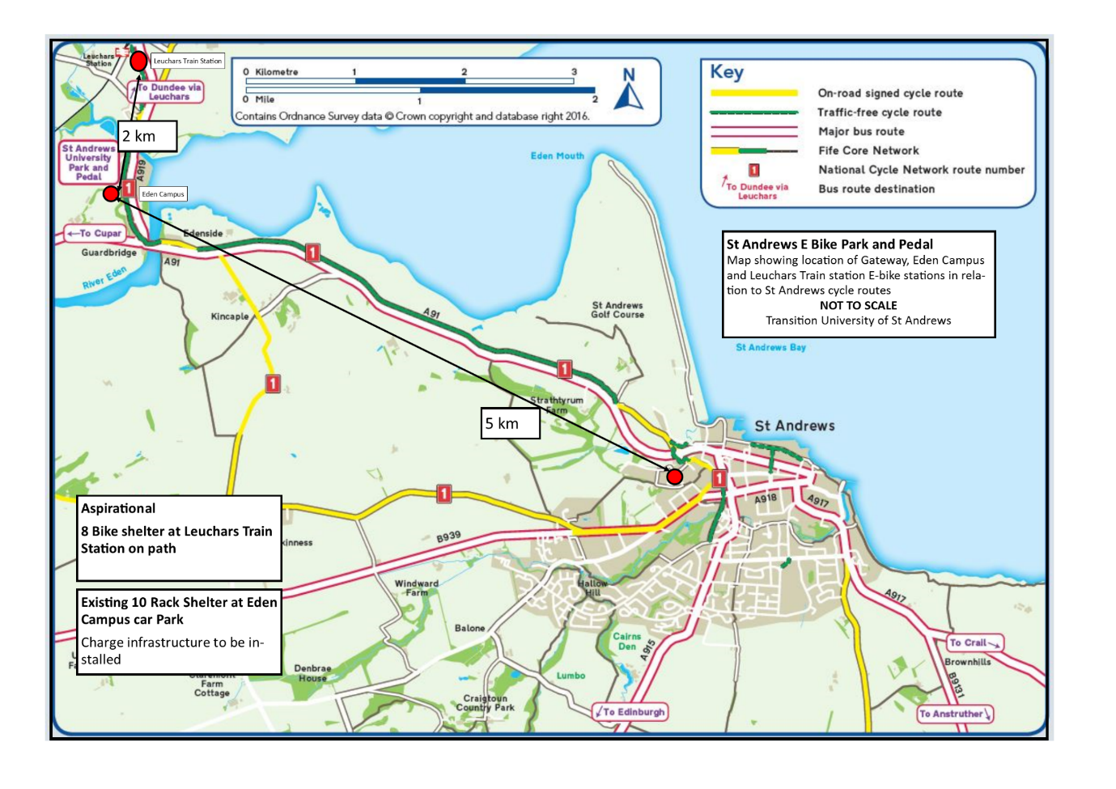
Figure 3 Location of Leuchars and Eden Campus in relation to St Andrews

Current situation
Twelve, Gazelle Orange C7 HMB, E-bikes were fitted with the App Bike smart lock from Active Cycling Projects in May 2018. Our first two locations at Woodburn (Estates) and Gateway were completed in June 2018 with the College Gate shelter opening in late January 2019. Eden Campus and Old Borough School sites are expected to be up and running in April 2019
Staff were required to undertake a short induction into the Go E-Bike’s as part of the Universities Health and Safety procedures to check on competence and provide some guidance. Initially, this was seen as a barrier to take up, but this concern has not been born out by the bookings. The first cyclists were trained on the 18th June 18 and, since then, over 100 members of staff have undertaken training.
The Training sessions, whilst potentially off putting for some people, have been very well received with many attendees saying that they found the courses helpful in going confidence to get back in the saddle or that they learnt new skills / stopped making poor decisions.

Usage
Of the 102 staff trained between June 18 and March 19 only 34 people have gone on to rent a bike with 13 being regular users (more than 12 times).

The above chart shows that the operator account has the highest usage which include maintenance and training sessions. We then have around 12 regular users and a large number of one off or low frequency users. We are concerned that a large number of staff are undertaking the training but not making that initial rental. This is common amongst other on demand “hire” schemes such as car rentals and shows more work needs to be done on getting users to make that first hire during induction.
The gender split is roughly equal for training as with usage.
The Gateway is the most well used Hub with its 5 bikes going out over 80 times in the 4 months of operation.

Anonymised usage data for Go E-Bike June2018 to Feb 2019
Base | Bike | Time on hire | Trips
Woodburn | 4001 | 586 | 71
Woodburn | 4002 | 386 | 84
Woodburn | 4003 | 259 | 59
Woodburn | 4004 | 583 | 84
Both | 4005 | 67 | 27
Gateway | 4006 | 310 | 70
Gateway | 4007 | 201 | 70
Woodburn | 4008 | 51 | 22
Gateway | 4009 | 151 | 56
Not in service | 4010 | 0 | 4
Not in service | 4011 | 0 | 2
Gateway | 4012 | 98 | 14
 | Grand Total | 2693 | 563

Most bike hires are of small duration with over 44% of hours being less than 3 hours. There is a spike occurring at 8 hours and 15 hours hire duration which correspond to an all day hire (9am to 5pm = 8 hours) rental or overnight (15hours). In this early stage of the project we have been encouraging staff to take the bikes as they see fit including commuting. Anecdotally, we know many of these longer hires are displacing car journeys and we will hope to see more of this when Eden Campus Park and Pedal comes on line in April

Operational update
The E-Bikes have an annual maintenance check in January plus weekly checks as part of the battery replacements. Data downloads from the bikes shows half the fleet have been ridden for over 200miles with a combined total of 1814 miles. Almost half of distance has been undertaken without assist. This means that when the bike reaches the 17mph maximum the assist switches off and the cyclist is the only power.

Scheme Totals
odometer / Miles | 1814.54
operating time/hours | 375
distance in turbo / miles | 645.6
distance in sport / Miles | 142.2
distance in tour / Miles | 151.7
distance in eco /Miles | 202.9
distance in no assist | 670.7
charge cycles | 43.2
electrical charge lifetime /Ah | 429.8

Feedback
The bikes have been performing well with very few issues – one burst tyre and 3 gear adjustments. Here are some quotes from 3 different users:
I’m LOVING this scheme. Thanks so much to you and all the folks who made it happen. Bloomin brilliant
5 minutes to travel between Gateway and the OBS – easy peasy. Didn’t even break a sweat…. And no worries about getting a parking space.
LOVED IT!!
Why I love using the University e-bikes.
I love the e-bikes. I get on an e-bike, and it just works. The tyres just work. The brakes just work. Rust and grease do not mar my trousers. The batteries that power the light just work. There is no fiddle. There is no faff. I do not have to find a spanner, or an air pump, or a tyre puncture kit, or a screwdriver, or pliers, or find the detachable headlight, or charge the headlight batteries.
It just works. It is a joy.

Things to work on

However, we have also had some issues including
- Micosoft OS phones don’t have an app
- High number of lock opening/ closing failures relating to lock batteries need replacing or resetting
- More locations needed
- Battery replacement takes place every Friday which seems to be enough at this level of use but has occasionally led to batteries running out
- Main barrier is the path to Guardbridge
- Helmet use leading to Helmet hair is off putting
- App signs you out irregularly meaning you have to re-enter password
- Password resets contain long mixed character sets whereas App only allows capital letters at start

Battery’s are currently swapped once per week at both sites alongside a maintenance check. This seems to be appropriate at the current user levels but we are noticing that the batteries getting increasingly close to empty as more users come on to the scheme.

Site development
Eden Campus Park and Pedal is now open but we are awaiting new bikes before placing the Go E-Bikes on the site in April.

Leuchars Train station requires a TPO to install a shelter within Fife Councils car park. A design for this and costing will be sent to COMOUK

With Staff not moving to Eden Campus now until the end of 2019 it would be useful to trail out a couple of other locations on a temporary basis to get them used to the bikes and the bikes in use. We would like to establish a temporary hub at the Old Borough School and Observatory to facilitate this

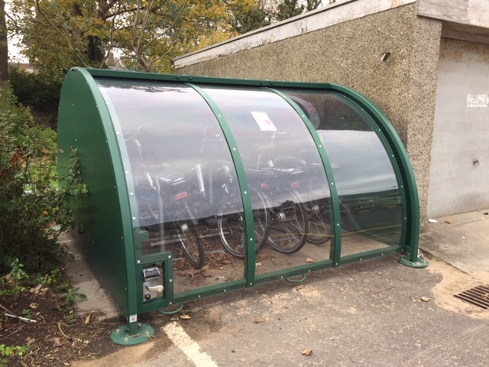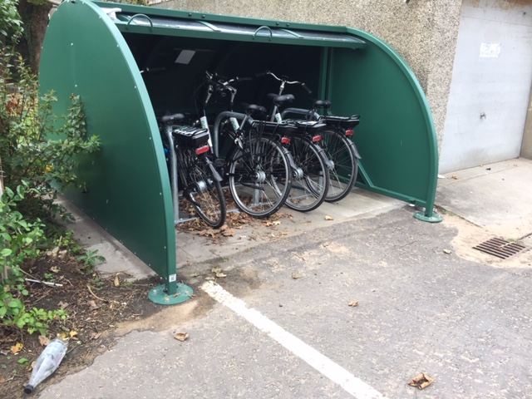
The shelters we are using are these Broxap Hangar style which fit 5 bikes. The pin access panel is fixed and given out only to staff once they have completed the scheme.

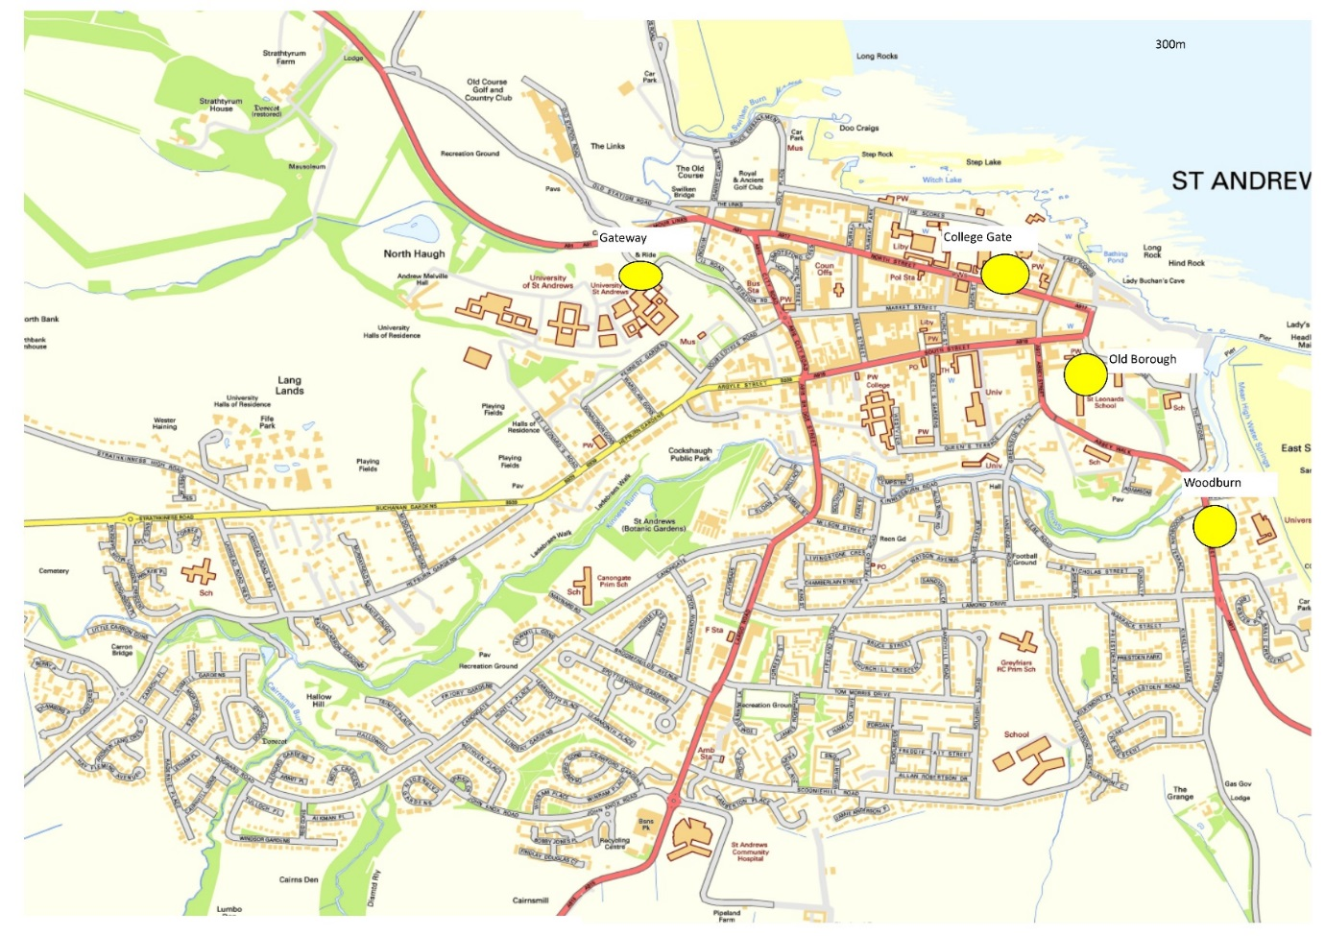
Figure 4 Town Centre Go E-Bike Locations

User survey
23/10/18
17 respondents via Survey Monkey

The sample of 17 people from 48 registered users was probably biased towards those that use the bikes regularly. The majority of respondents feel they use the bikes on a daily rate mainly for journeys of around 1 to 2 miles. This group mean is 3.6 miles per day.

The main travel mode displaced by this sample is walking before personal car. If we multiply the average distance by the frequency of mode displaced

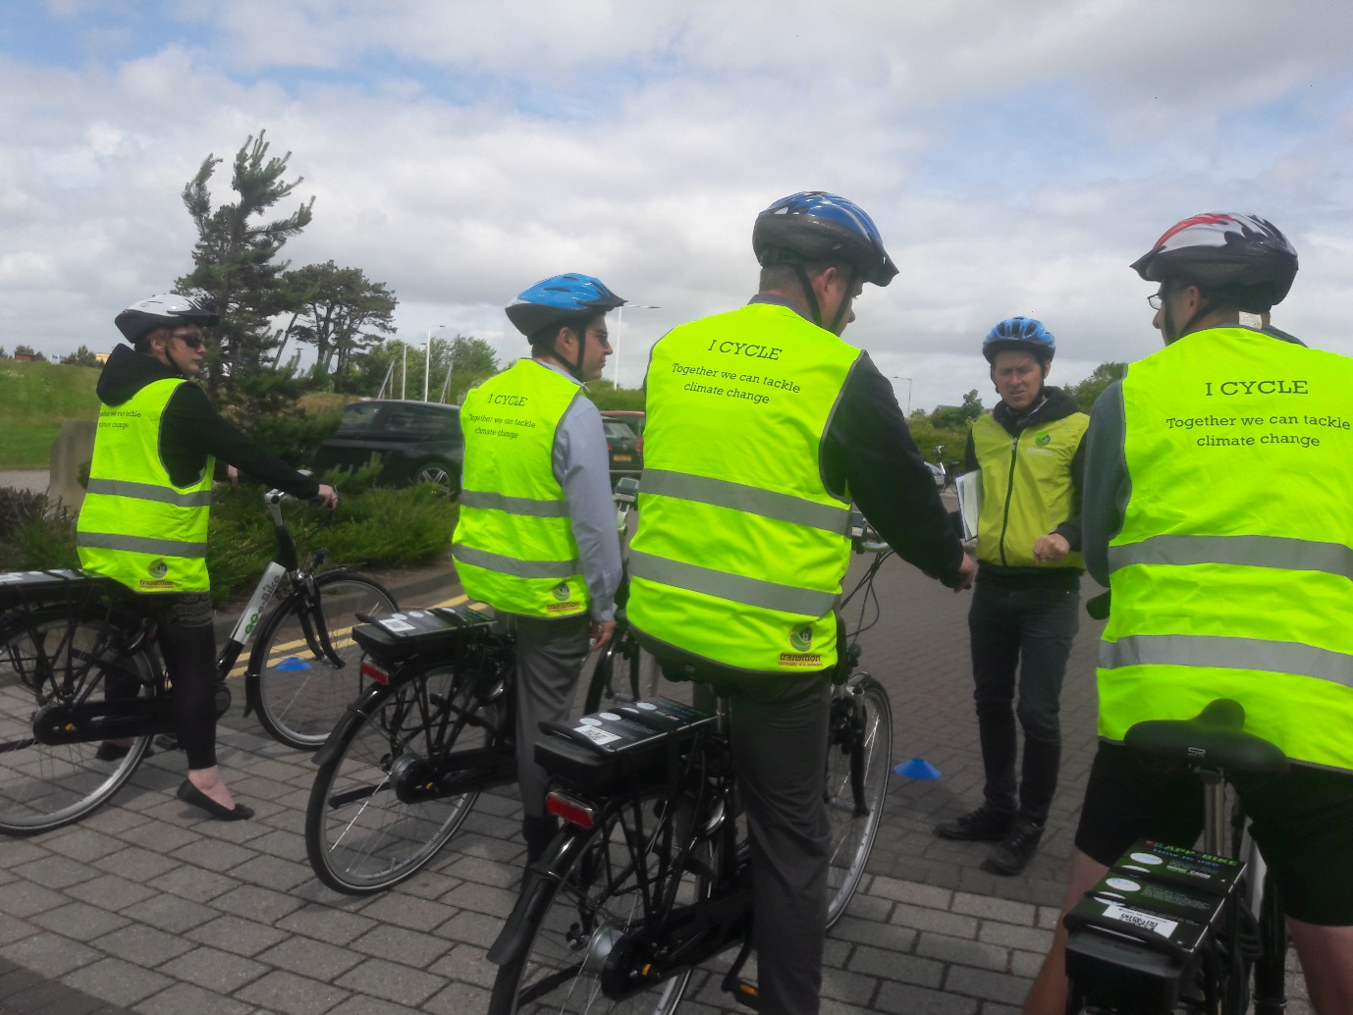

Crail to St Andrews Shared Path

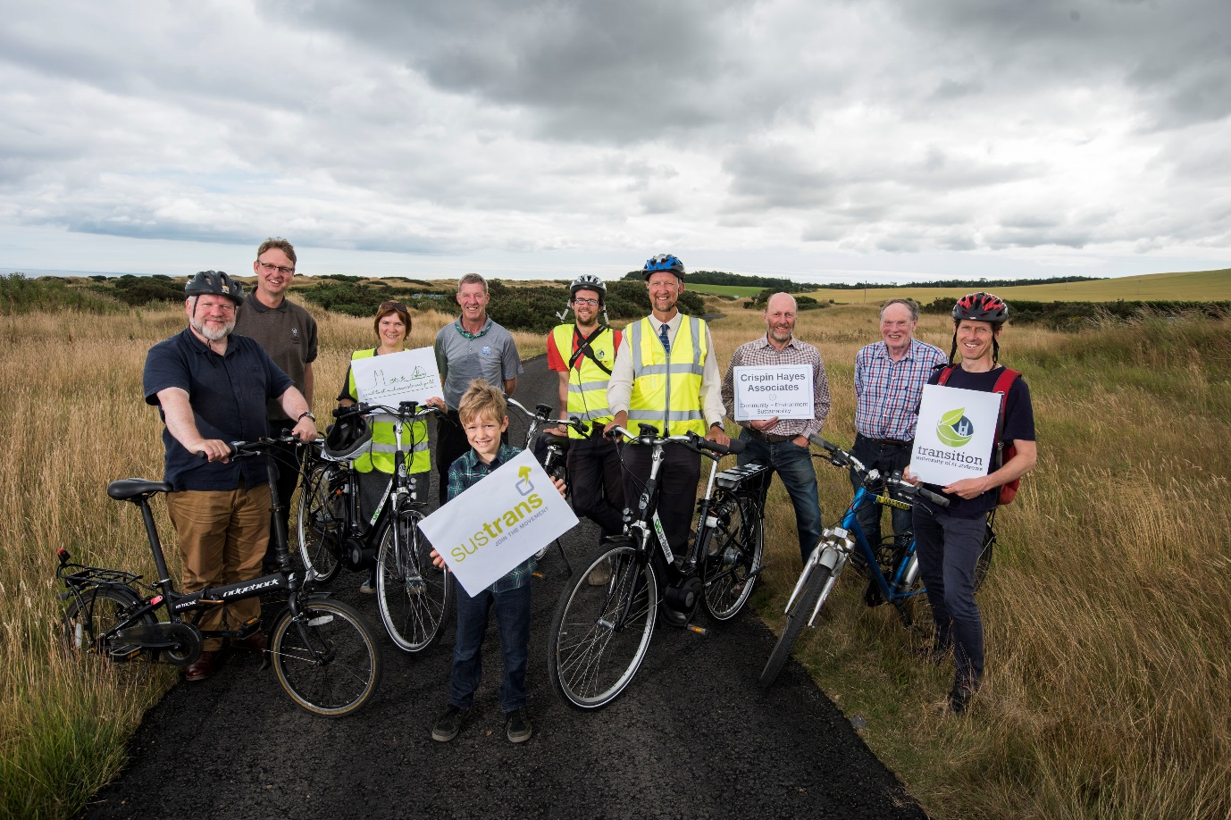

Overview
This project aligns with the Universities target to reduce single person car use by providing staff and students in the area with a safe off-road shared path so they can safely get to work without needing a car. It was initiated by the Bike User Group and supported by the Vice Principal for Enterprise and Community in 2016. Funding from Sestrans over 2 years helped build awareness and start the process of investigation. In 2018 we received a £39,745 grant from Sustrans to undertake more in depth consultation and land owner negotiation for the whole route and a further . £8530 for engagement and publicity. In order to deliver the project Transition has hired a Path consultant to deliver this work on behalf of the communities.
This years programme was a the feasibility stage: making a case for the path to be created along the old railway route from Crail north to Boarhills, and from there along new routes to the east of the A917.
The public consultation in 2016 had a great response from over 350 people. It showed overwhelming support for the new path route. It also showed that many respondents didn’t cycle because they were frightened of the fast traffic on these roads. This supports the development of an off-the-road shared use cycle path that would provide fast, safe and direct connectivity for communities and the many tourism-focussed businesses along the route. It will also enable those who were really concerned for their safety to be able to get on a bike.

Issues
By Feb 2019 it was clear that the proposed route we had been working on for the past 3 years had some fundamental flaws due to significant stakeholders being unwilling to agree on path route including the finsal section into St Andrews. The objections were summarised and discussed by the group along which led to the consultant developing a new route that took into account these objections and would be expected to met with agreement from land owners.

Future work
A second application to Sustrans has been submitted in May 2019 for a further year of Feasibility, legal negotiation and design work on this new route. The communities along the route are very keen to see progress on the design stage with a view to starting construction on a first phase of the path as soon as possible
http://www.transitionsta.org/travel/east-neuk-multi-use-path/

Travel – Reducing Car Use

Overview
In line with the Universities Travel Plan, the main focus for Transition work on travel continues to be the reduction in single person car use. This is undertaken through encouraging the uptake of shared car use, promotion of public transport and supporting the car free agenda within the community.
With support of the Smarter Choices Smarter Places fund we helped run St Andrews first ever “Global Car Free Day” on September 22nd. We worked in collaboration with local cycling pressure group, St Andrews Space for Cycling as well as Fife Council, Cycling Scotland’s Bikeability Coordinator and the St Andrews Students Association Community Relations team. It was a successful event which has resulted in more than 3000 people walking through a car free Market Street. A subsequent market research survey was completed and published that shows concern amongst local and shopkeepers for pedestrianisation but support for future events.
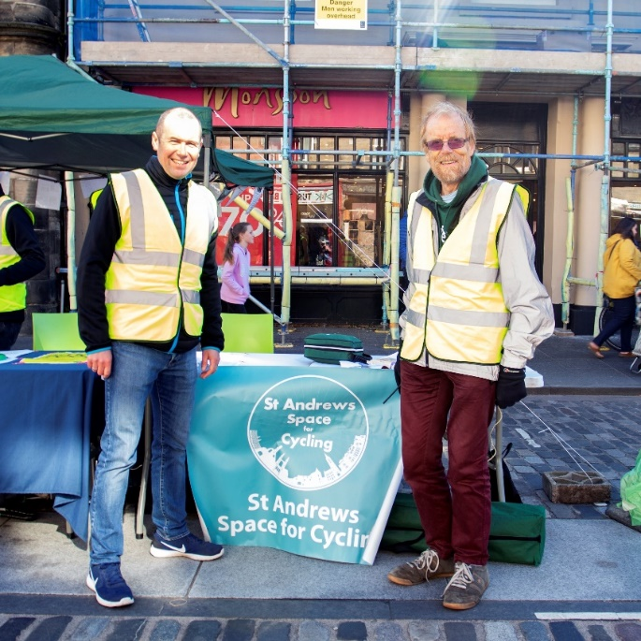
St Andrews First Car Free Day, which show The Clan, Scotland’s Cycle Stunt Team, performing dare devil stunts in a packed, pedestrianised Market Street, plus a stall used by St Andrews Space for Cycling, whose aim is to make St Andrews The Most Cycle Friendly Town in Scotland. Chairman Tony Waterston and Cllr Brian Thomson pictured.

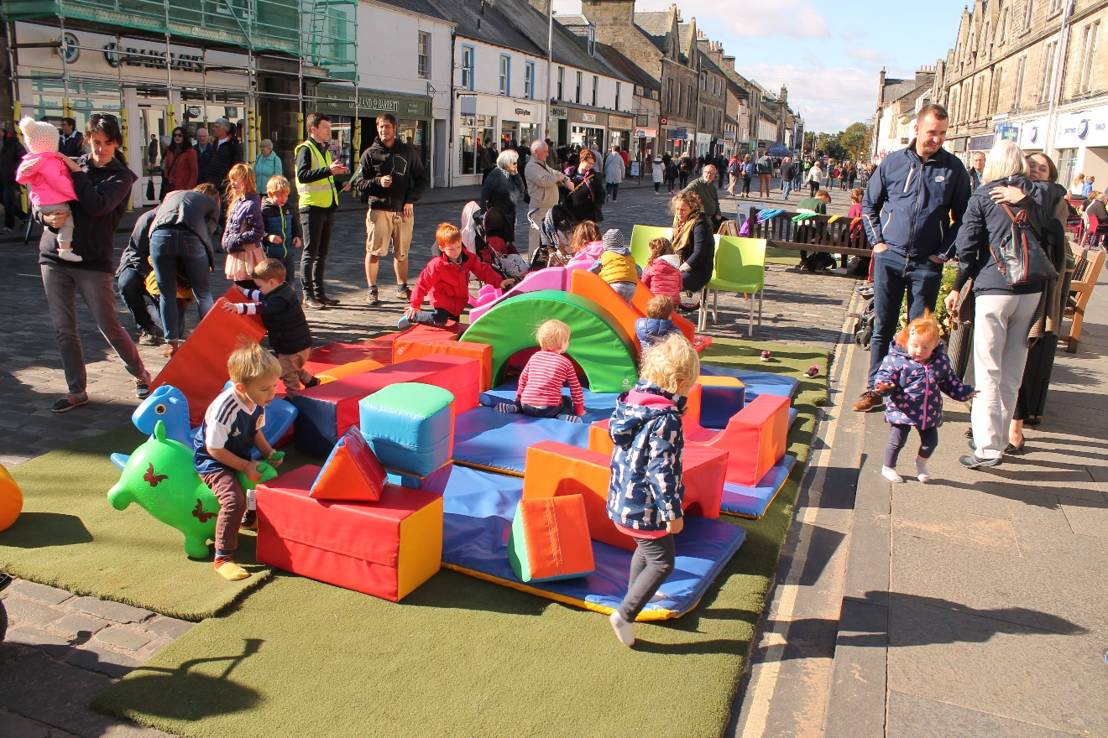
The sun shone on the morning of the event which started with people keeping to the pavements then as the day wore on slowing moving into the street and taking over the space, with parents making use of the soft play area and the astro turf provided by St Andrews Golf Trust.
There was also a yoga class and an African drumming session held on the day, plus a half pipe skateboard ramp was hired and made use of by children of all ages, who were carefully guided by staff from King Ramps, who I hired the ramp from.
Other events which took place on the day included a Bikeability session with Shealagh Crabb, Fife Bikeability Coordinator, led walks by the Edible Campus team and a led bike ride by St Andrews Space for Cycling. Transition provided a smoothie bike which was well used and a number of students volunteered to undertake feedback surveys and to politely police the entrance and exits of the street.
A survey of all the shops was done in advance in person by myself, offering everyone the opportunity to voice concerns and to offer help where we could. Some opposition was voiced by a number of shop keepers who felt their takings would go down and by some of those with elderly relatives living on the street who needed access.
However we gave access to those that needed and actually found that the carers of the elderly relatives did not need access and we also accommodated the guests of a wedding which took place in Forgan’s restaurant on Market Street on that day.
The results of the market research survey were published in the press recently and the outcome was that a report was written in the local paper and initiated by local Fife Councillor Brian Thomson. The primary objective of the report was to collect opinions of town residents, community organisations and businesses and to “research the feasibility and desirability of pedestrianisation through case studies and primary data collection.”
Opinions were collected through a combination of surveys, focus groups and interviews and data through Fife Council and St Andrews Space for Cycling as well as Playfair themselves. It did not just include data collected on Car Free Day.
The key findings were that most residents and businesses wanted ‘no change’ but one third of respondents indicated “a preference towards some form of pedestrianisation.” The final report issued by Playfair indicated that residents “fear losing vehicle access and on street parking would deter people from using the street, with businesses suffering as a consequence.”

Liftshare
Since 2017 we have recruited 188 members to the University St Andrews private Liftshare Scheme and created 10 teams. We had a very successful Liftshare event in which we gained over 100 members to the scheme bringing us to a total of 372 members in total and 15 Liftshare teams.
This brings our money savings total to £6,803 with a reduction of 11 tonnes of carbon and 57,987 miles saved.

Signage to encourage walking and cycling
Travel mode surveys outside the Universities largest halls indicate that students and visitors will often take taxi’s or cars for trips into town. The reason for this might be complex but we assume that many decisions are made through lack of local knowledge.
To address this we installed seven “Share with Care” signs along the main shared path from the largest University accommodation areas at David Russel and Agnes Blackadder Halls and four finger posts directional signs. The aim will be to signpost tourists, students, local residents and potential new school children into town via the Shared Core path and reduce quick decisions being made to call a cab or jump in the car.
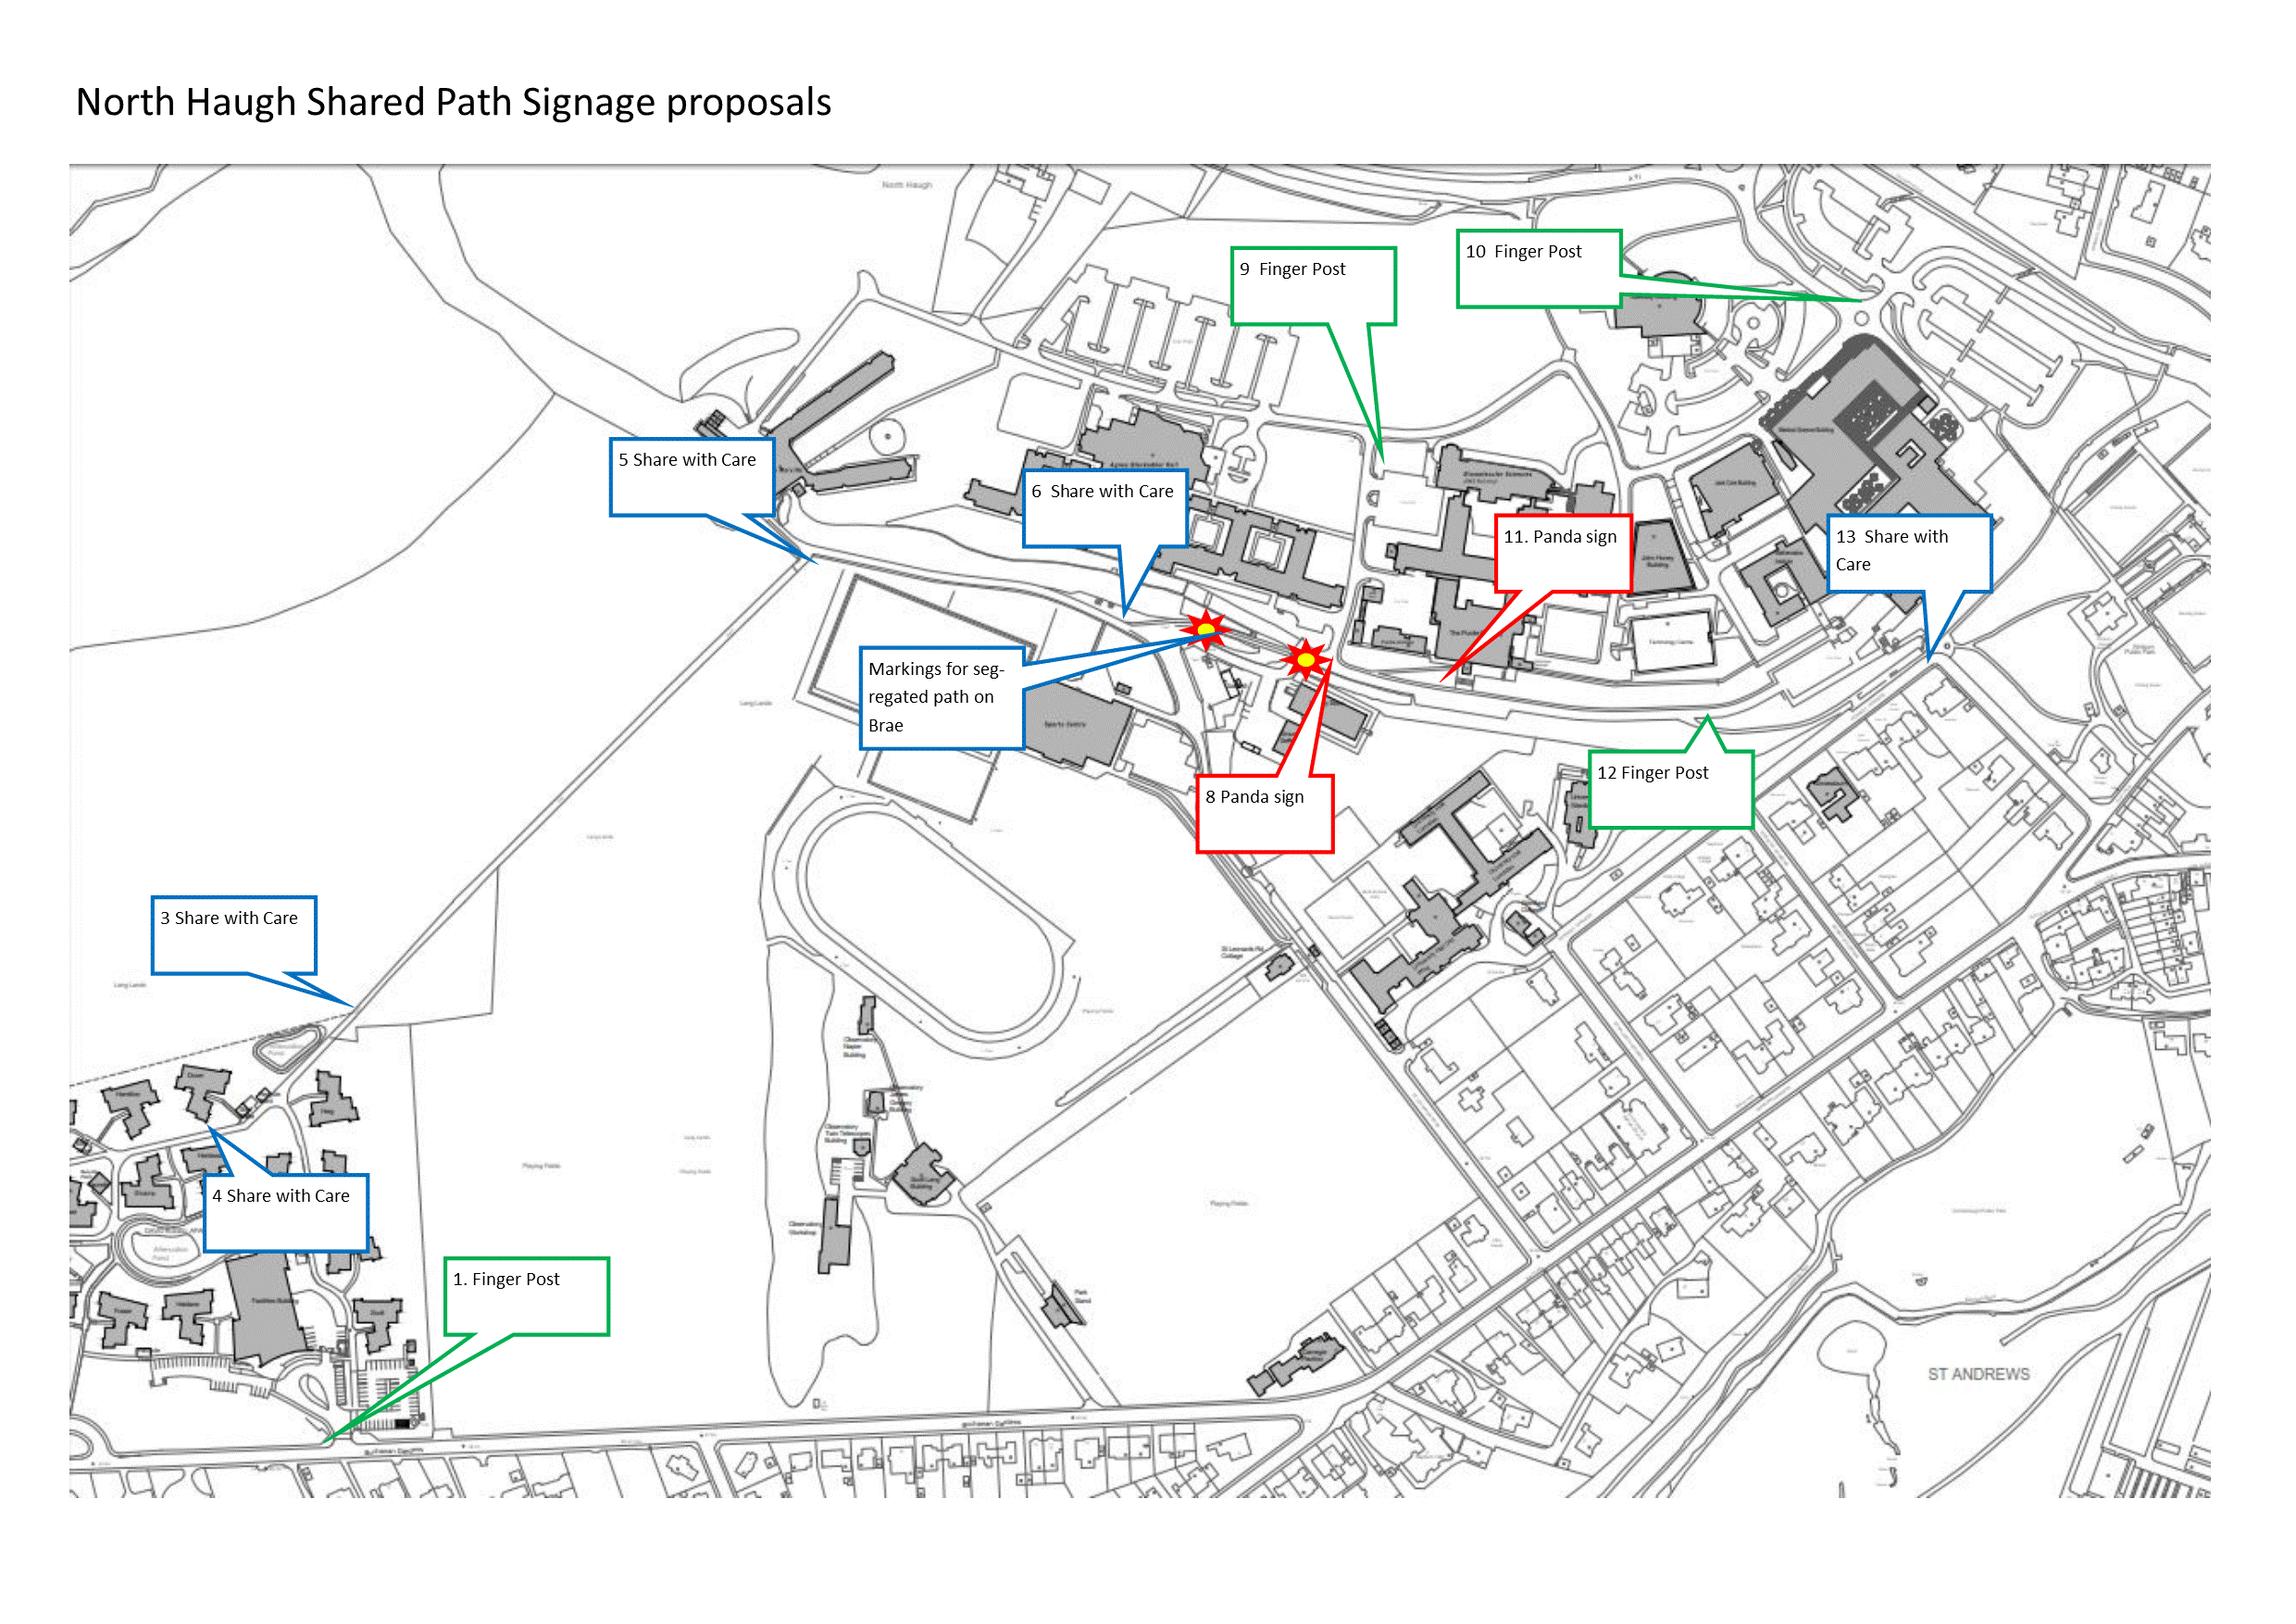

St And re-use

Overview
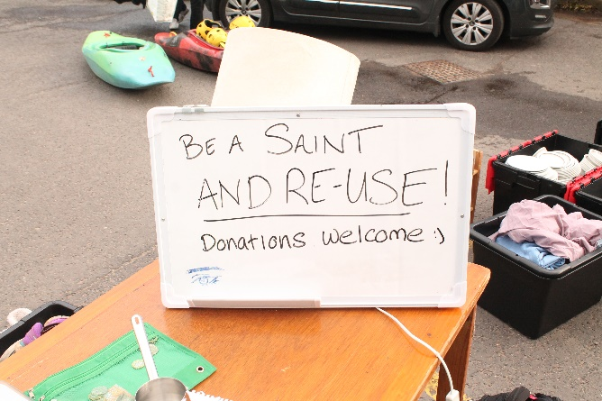
Since 2012, St And Reuse has grown significantly despite a brief lull in the amount it was able to manage from 2015 to 2016. In the past year however, the project has seen its greatest success with collecting and redistributing over five tonnes of reusable goods and reaching out to over 800 people, not including two local community groups and one church that were also supported. The estimated financial value came in at over £50,000, truly capturing the high value of the items handled and the project itself.
Nearing the end of the academic year, preparing for another round of collections, we have managed to fit almost all donated items into a single shed. We estimate that some 69% of the items have been rehomed.

Year | Weight (kg) | Monetary Value Saved (£) | No. of People Who Benefitted | Volunteer Time (Hrs)
2012 | 274
2013 | 450 |  | 420
2014 | 1000 |  | 510
2015 | 4100 |  | 712
2016 | 1606 | 18,690 | 534
2017 | 2876.6 | 26,240 | 595
2018 | 5289.3 | 50,285.5 | 819 | ~290
Table 1 Statistics Tracking St And Reuse Since 2012

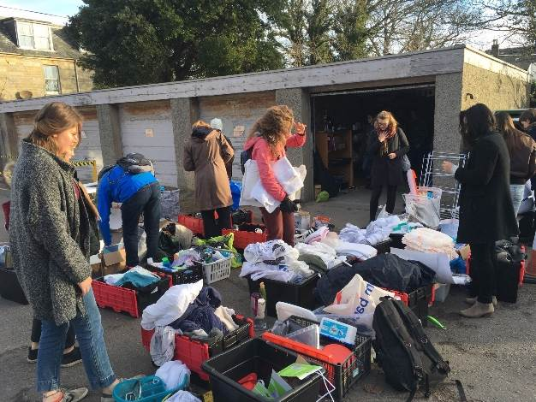
Volunteer Engagement
- 68 Volunteers participated in sorting
- Approximately 290 Volunteer hours clocked
- Assistance from the St Andrews Environmental Network and the Clean and Green team with transporting donations from halls of residence:
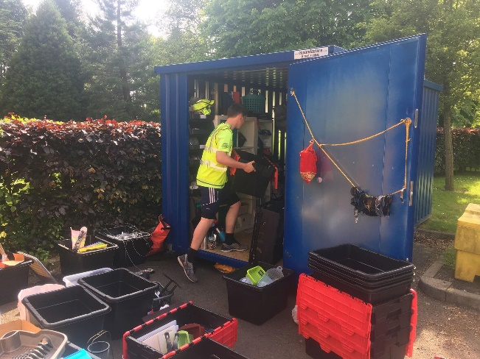
  - 27 Shuttle runs to halls collecting boxes over summer
  - 110 Volunteer hours
  - Collected from 5 halls: St Salvatore, John Burnett, Agnes Blackadder, Albany park and University Hall

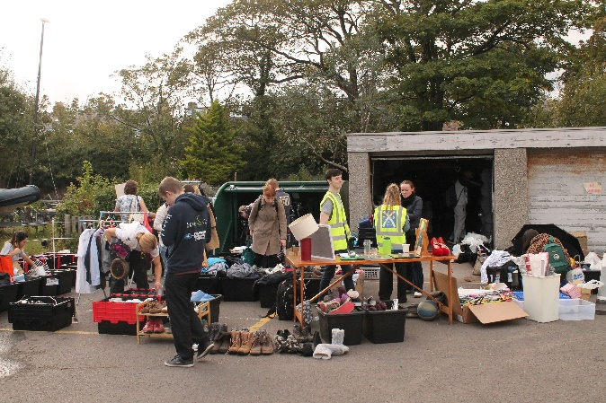
Additional Information
- 9 Halls of residence were involved in St AndRe-Use; one collection point set up in the Union.
- 44 Collection runs including the Transition team picking up donations from halls of residence
- 65.56m² of space used for storage
  - Main shed: 5.6m (length) x 2.7m (width) = 15.12m²
  - Bike Pool Loft: 5.2m x 4.7m = 24.44m²
  - Estates Storage Shed: 6m x 3m = 18m²
  - DRA Reuse Hub: 4m x 2m = 8m²
- Facebook Group – St AndRe-Use
  - May 31st – 1,709 members
  - July 31st – 1,730 members
  - September 30th – 1,792 members

Sustainable Style St Andrews
Over the second semester (2019), St And Reuse began supporting a student-led initiative called Sustainable Style St Andrews, aiming to promote second-hand fashion in the fight against an unsustainable fashion industry. Transition UStA provided the clothes to run their first event, which took place on the 1st of March, titled “Thrift Fashion Fayre”. People swapped in clothes for tokens to shop with. Others paid for items on the spot.
- 80 people attended the fayre; the vast majority being students
- A profit of £258.79 was made from a combination of ticket sales and clothing sales
  - 50% of the profit went to Transition’s St And Reuse project
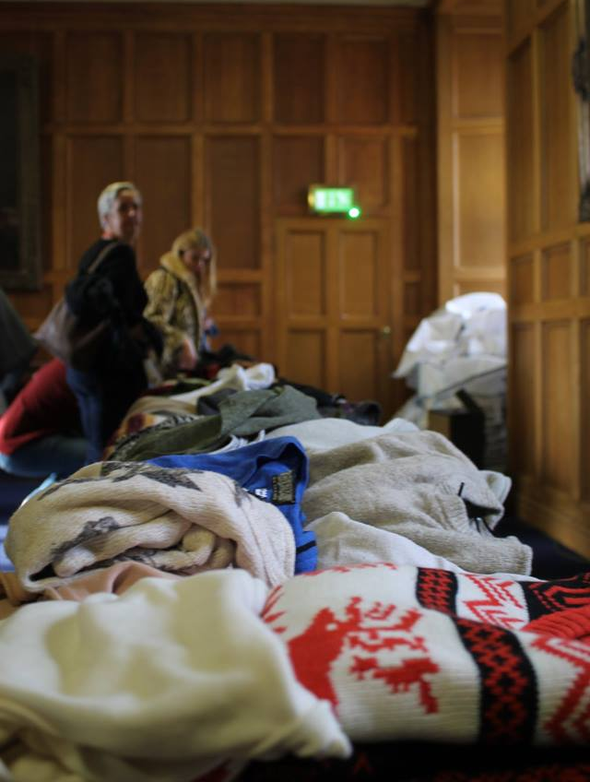
  - 50% went to Frontline Fife, an organisation tackling homelessness in Fife
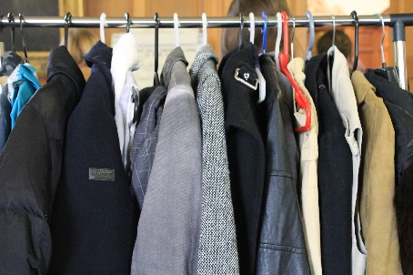
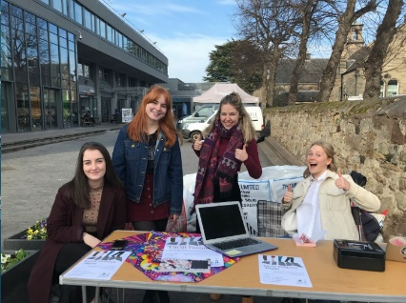
- Supporting the sharing economy concept, 406 items of clothing were donated to be swapped. 155 items were sold

Reporting: Carbon
Project | material | Weight of Material /Kg |  |  | CO2e Savings/tCO2e
 |  | Repaired/ upcycled | re-used | swapped/lent
clothing | Clothes and accessories |  | 1956 |  | 41.2
electronics | WEEE | 572.00 |  |  | 1
kitchenware | Metal | 2132.00 |  |  | 8.3
cutlery | Metal | 676.00 |  |  | 2.6
glass and mugs | Glass | 468.00 |  |  | 0.6
stationary | Paper and card |  | 624.00 |  | 0.9
coat hangers | Plastics | 213.00 |  |  | 0.7
Total |  |  |  |  | 55.3
In the past St And Re-use has avoided re-using clothes, bedding and duvets due to the issue of storage and display for re-use. By teaming up with groups/volunteers keen to work on clothing re-use we were able to prevent considerable waste going to recycling rather than re-use.

Reflections and Future Directions
- With St And Reuse taking on a wider variety of items to manage, including clothes, bedding and shoes, there were significant challenges in handling due to a lack of preparation. To the point where we lost a large amount of clothes to landfill and recycling. What we did manage to handle was put to good use by the student group, Sustainable Style St Andrews, who promote second-hand fashion in St Andrews and raise awareness about the detriment of fast fashion.
- The success of the reuse has predominantly relied on the measuring the quantity of items collected, sorted and rehomed. But with storage space not getting any greater, a new future aim for the project is required; instead, we should aim to prioritise reduction over reuse.
- Over the next summer St And Reuse will change dramatically with greater involvement from different organisations including the British Heart Foundation, a student led foodbank support group called St Can-drews, Barnardos and the St Andrews Environmental Network. The University’s print and design team is producing a single leaflet to consolidate all information about the reuse scheme, which each student in a hall of residence will receive.
- Transition will be trialling on-site storage in one hall of residence, St Salvatore’s, in an attempt to expand storage space, further localise reuse efforts to each halls and enhance student engagement by exposing the reuse items to the primary stakeholders, the student residents themselves. And another trial is looking at establishing a more extensive inventory of household items in a single block at another halls, David Russel Apartments, to reduce the need for students to buy new.

St Andrews Community Skillshare

Introduction
Skillshare was first established in St Andrews as a Transition University of St Andrews project in May 2016. Over the past three years it has attracted over 1278 members and its membership continues to grow. The remit of the project is to help build a robust and cohesive community bringing together both students, staff and the local residents. The project offers a wide range of skills with the aim of supporting the community to move towards a low carbon lifestyle.
Over this past year we have run 138 skillshares, attended by over 900 attendees. The skillshares offered have ranged from smart cooking classes and clothes upcycling to Chinese tea ceremonies and making animals from felt.
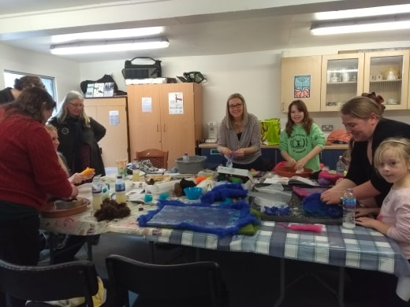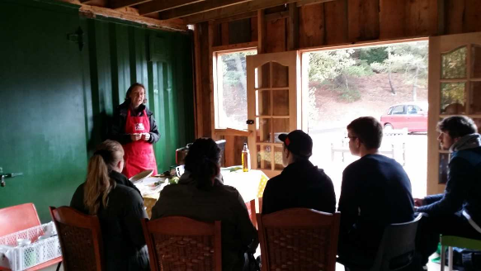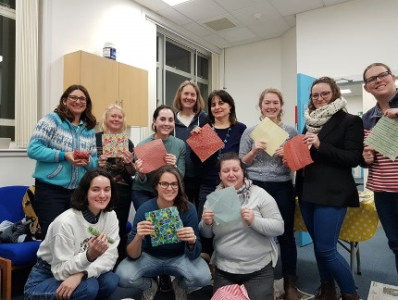
Figure 7 Wet felting Leak and potato soup Wax wraps

Volunteer support and Partnership Working
This year we have had the support of a great team of Interns (Ella Jackson, Sarah Latimer and Moly Paechter) and this has enabled us to massively increase the number of skillshares we have been able to offer. Feedback from the community also suggested that the community would like more skillshares offered by the community rather than professional trainers, and so we have worked hard to improve the mix of skillshares being offered. With the help of these volunteer skillshare trainers the community has given us over 870 hours of support though the year.
As well as volunteers we have also continued our ongoing relationship with Patrick Bowden Smith at Pittarthie Farm and he has offered us two to three skillshares a week, including pallet upcycling and cot upcycling as well.
As the St Andrews Community Tool Share Group has grown, we have been able to work in partnership with toll share to run skillshares, This has helped the community to learn to use the tools that tool share has on offer. Winks Emmerson has run sessions on sign making with a router and wooden spoon making with a Dremmel and these have proved very popular.
We have also run a few Cosy Homes sessions with St Andrews Environmental Network and they have been well received by the community…
Pam Brunt has also been a superb volunteer and offered us two sessions a week for clothes upcycling and intro to sewing machines sessions. Pam also has run a clothes repair service for Transition, enabling us to save even more carbon.
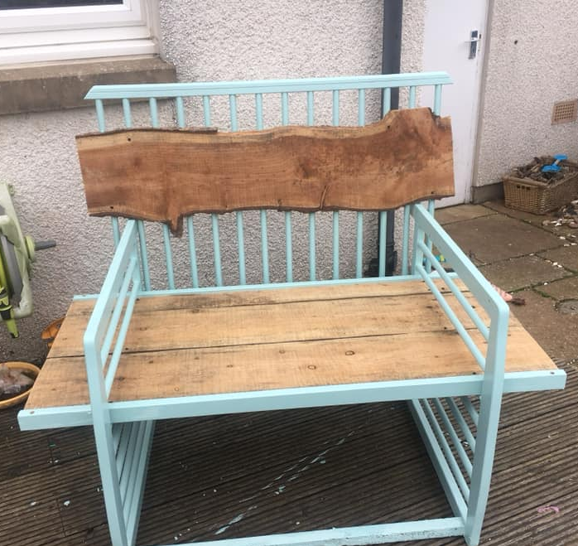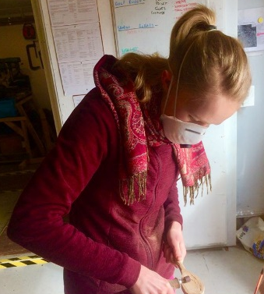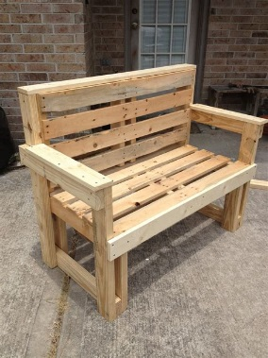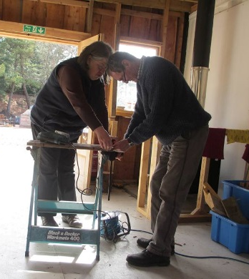
Figure 8 Cot upcycling Wooden spoons Pallet furniture Sign making

Permaculture Gathering
Transition University of St Andrews worked closely with Permaculture Scotland to host the Permaculture Gathering in 2018 in St Andrews. We ran it as a fully catered camping weekend with lectures and skillshares running for the two days. The event was attended by over 100 people and in total we clocked over 400 hours of volunteer time. The theme of the event was Climate Change and the opening speech was given by Maddy Harland.
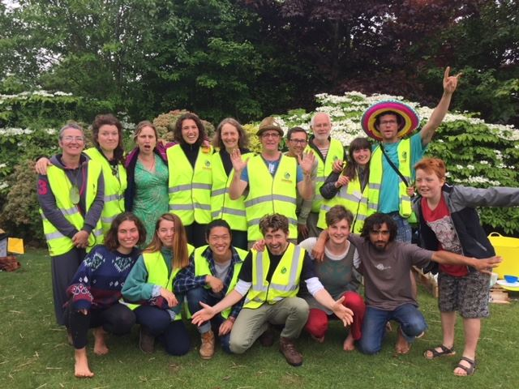
Figure 9 The volunteer team
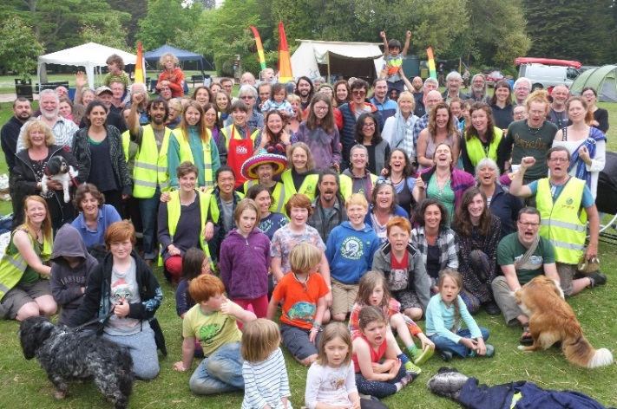
Figure 10 The participants and crew

Monitoring
Monitoring and evaluation has continued throughout the year, with forms being handed out at the end of each skillshare to be filled in by participants. Data from the feedback form has given us the following data:

Origin of skillshare attendees
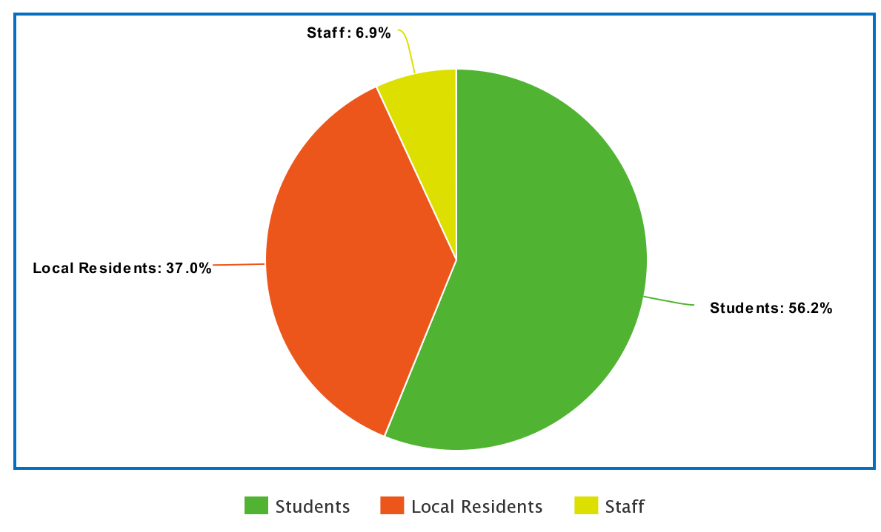
This pie chart suggests we have a good spread of people attending skillshare, from both the local residents and the student population, but staff are still underrepresented.
Mode of transport used to Skillshares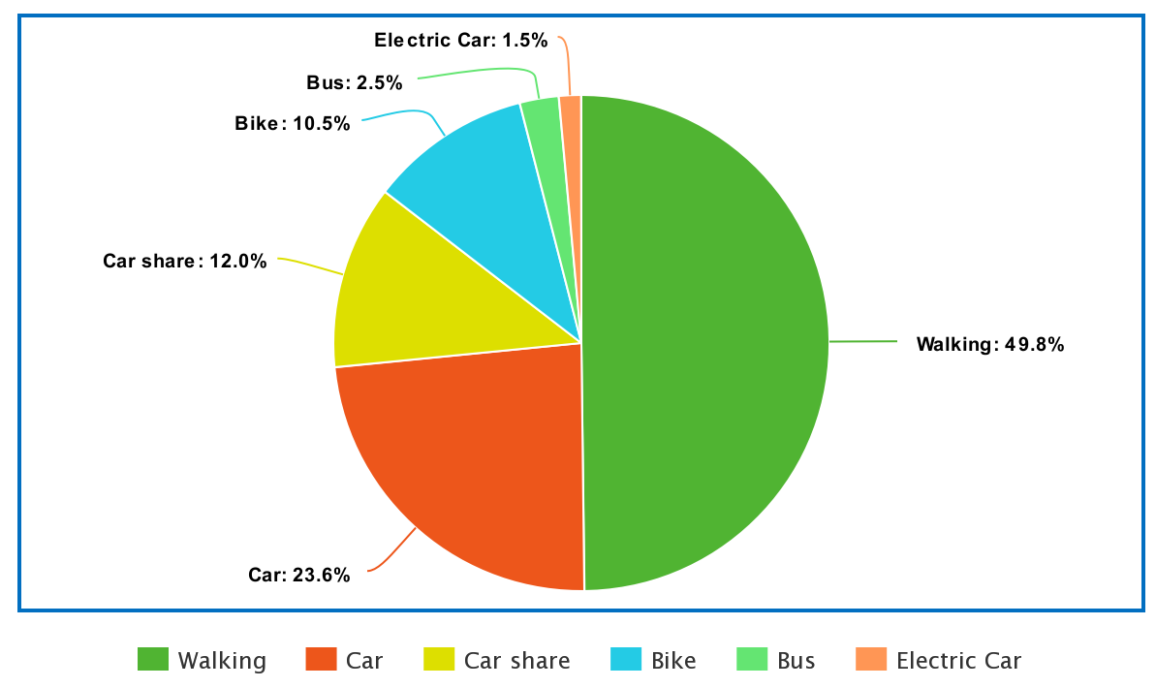
Transport to skillshare is dominated by walking and this has shown a significant increase from the previous year, replacing car travel as the preferred transport option. There has been a drop in the number of people traveling to skillshare by bicycle.

Outcomes
How much has your knowledge increased as a result of skillshare?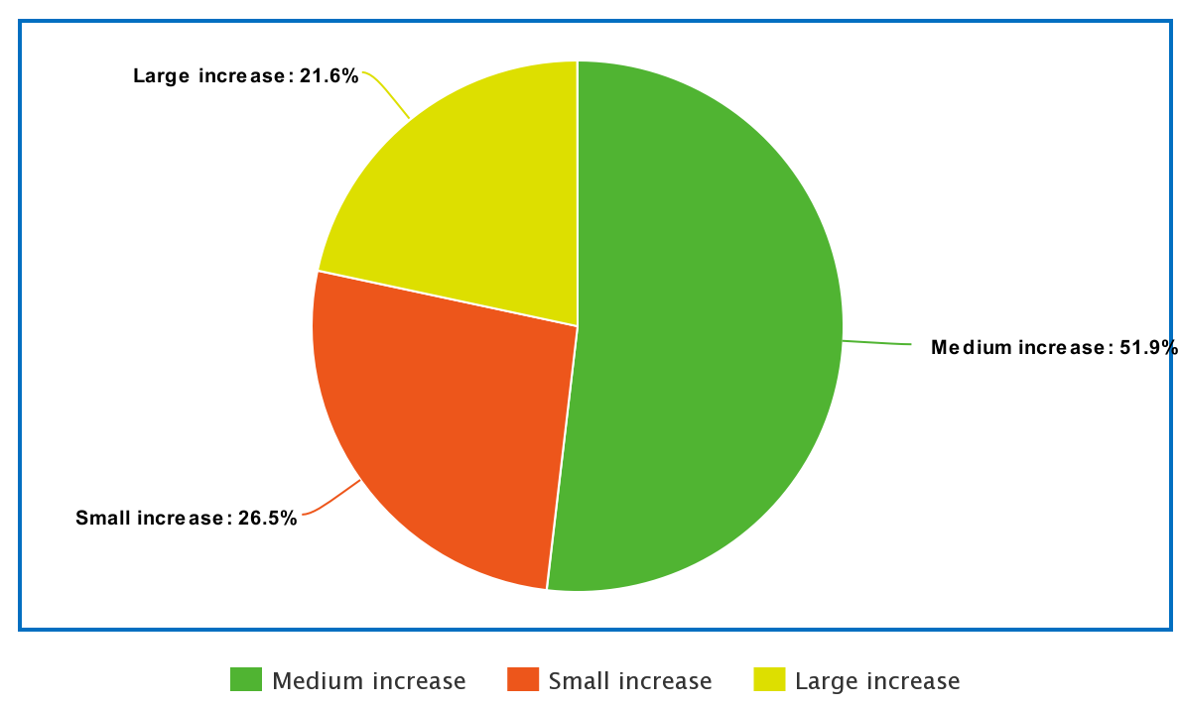
The feedback forms give us a good indication of how effective skillshare is at increasing participant’s knowledge. In total 70% of people indicated that they had had a medium to large increase in knowledge as a result of attending skillshare.
Do you feel more engaged with your community as a result of skillshare?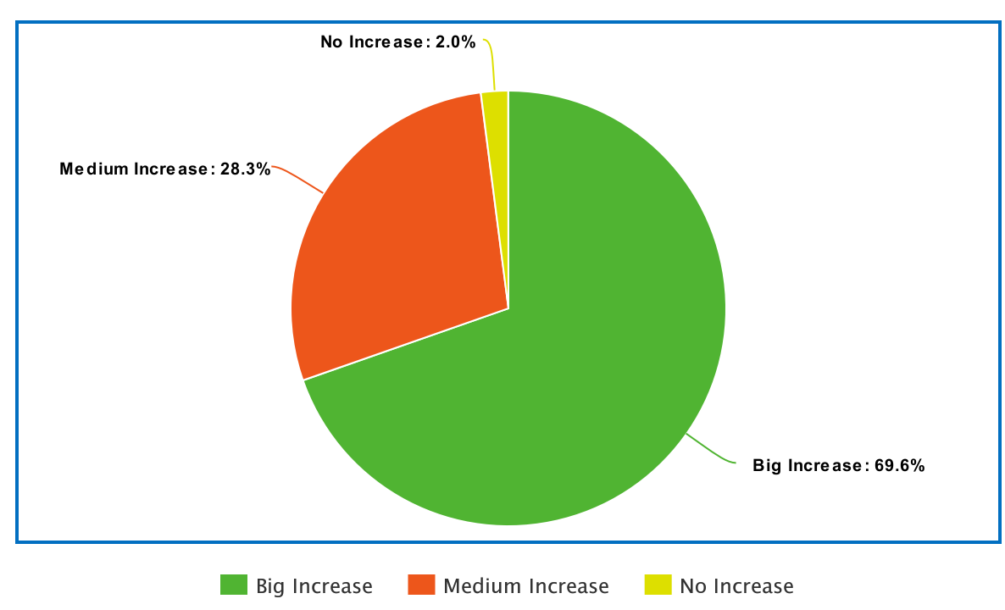
Community engagement is always a very important part of skillshare and the feedback suggests that people feel that skillshare plays an important part in helping them feel more connected to their community, this is also certainly backed up by anecdotal evidence…

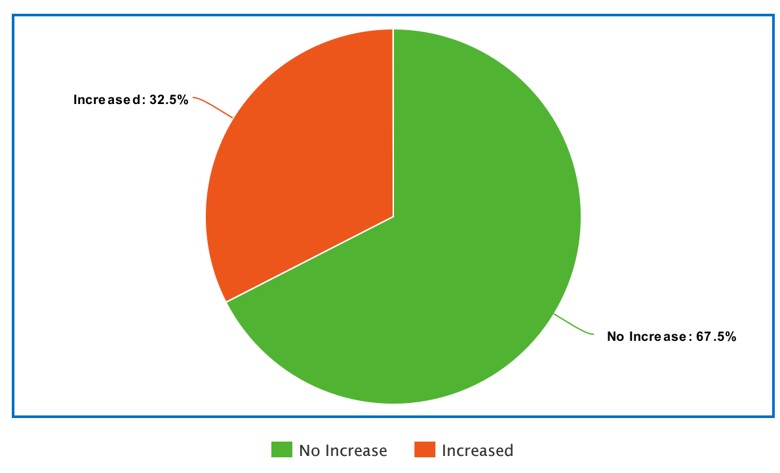
Figure 11 Please rate how much your knowledge of climate change has increased as a result of this skilllshare.
This chart indicates how much participants feel that skillshare has increased their knowledge of climate change. The question asked participants to rank their own knowledge before the session and then at the end of the session. Although it indicates that a significant number of people experienced no increase, this is in part due to the number of people who ranked themselves (accurately) as being very knowledgeable at the beginning.

Low carbon pledges made by participants
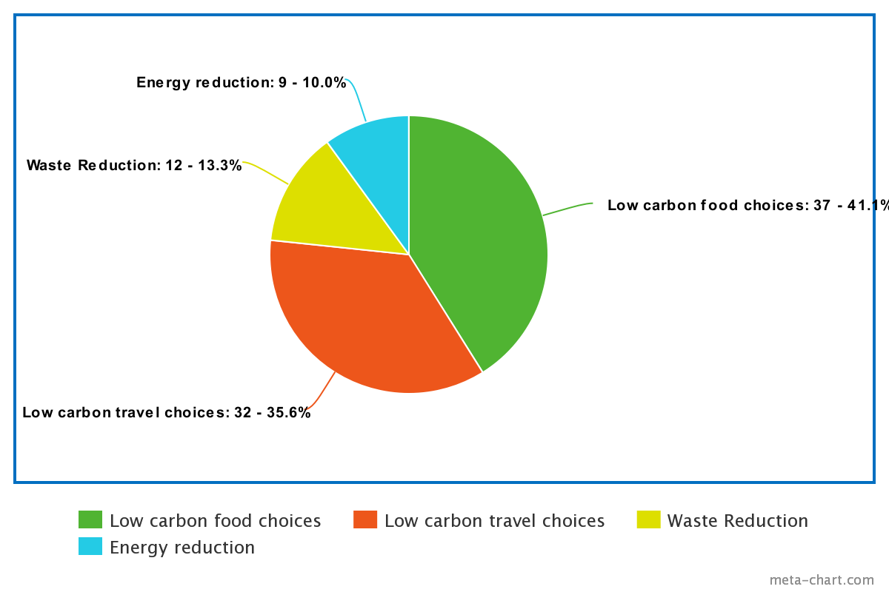

Participants were encouraged to make a low carbon pledge at the end of the session and this was recorded on the feedback form. Low carbon food pledges where well represented, which is to be expected as a good number of the session were focused on smarter cooking and waste reduction in the kitchen.

Challenges and opportunities for learning
This has been a very productive year and the project has been well received and supported by the community. We have been able to put on a record number of skillshares this year, mostly due to the hard work of the skillshare Intern Team. The total number of volunteer hours this year has been exceptional and had clearly has contributed to increasing the number of skillshares we have been able to run.
This year we have moved offices which has given us access to a new training room. Having different buildings throughout town has been very helpful as it increased the reach of skillshare across town.
We have faced a few challenges this year notably being unable to find anyone with leather working skills to offer any leather working skillshares. This is something that we can focus on next year and hopefully we will be more successful in finding someone.
Engaging staff remains an issue for Skillshare and I think this may well be due to a number of reasons. Firstly staff feel ready to head home after work rather than staying for a session in the evening. This is also compounded by the sessions often being held at 7pm which means that staff would have to either stay in the area or go home and then return later. Engaging staff will remain a challenge but placing adverts more regularly in our staff newsletters may well be helpful.
As skillshare has become more established we have been looking at how the project can be used to communicate climate change. In the past we have focused on using it very much as a practical tool for communicating messages such as reducing food waste in the kitchen, upcycling clothes and the benefits of a plant based diet. But this year we have begun to use the project much more as a communication tool for talking about climate change and our need to reduce our carbon footprint. We have tried a number of strategies and found that display boards, leaflets and encouraging group conversations have worked best as a tool for raising awareness. Members of the Transition Steering group have begun attending the skillshares regularly, and this has helped to broaden the conversations rather than the sessions just being trainer led. All this has really begun to add value to the sessions as a communication tool.
Feedback from the sessions is always very good. But every year we look at our feedback forms and check to see if the data collected is useful and the feedback forms are fit for purpose. This year we explored using a climate change question to see how effective we are at communicating the issue. However the design of the question meant that we actually got a very low rating for this part of the project. This was in part due to people accurately self-reporting that they had a good knowledge of climate change at the beginning and therefore there was not much room for improvement. However I think the question could be re written asking people to rate if they felt they had learnt some new tips for how to reduce their carbon footprint, and this may well create more meaningful data for next year.
We also experienced problems with the pledge part of the feedback forms. There was a high number of people pledging to reduce their carbon footprint with a generic statement. These tend to be fairly meaningless and unlikely to be translated into behavioral change. This is due in part to the phrasing of the question and also a staff training issue. In future when the forms are handed out, it would be useful for us to be very clear that we are looking for a practical and achievable pledge.
Over all our feedback forms would benefit from a rethink….

Feedback from Participants:
Kate Green Skillshare has been a fantastic resource. I have learned a number of new skills and met fascinating people. The focus on low carbon living has really opened my eyes to the possibilities of making small changes to help the environment and how these can be both interesting and enjoyable.
Emma Shanks Skillshare has been a fantastic resource for me. I have learned new skills, and engaged more in the community: having struggled recently with anxiety, I have found the relaxed environment appealing, and have connected with others. I've learned of new venues in St Andrews also. I've found learning about low carbon living really informative and have employed the knowledge acquired in my lifestyle and business. I think its an excellent initiative, which is run in an open and approachable way and as such is of high importance to the community of St Andrews
Johanna Gibson We enjoy being able to walk to Skillshares and learn from members of our community how to make, repair or share things so we don't have to buy new things. It has been very helpful for our "greener" lifestyle and me and my son have enjoyed it immensely, making several new friend in the process.
Sarah Breyfogle Skillshare was a really important way for me, as a uni student, to engage with my wider community. There aren't a lot of opportunities to do that, and this one really stands out as a lovely way of sharing the resources our community already has.
June Habibah Imrie 'Skills Share' has been an inspiring experience, learning new skills which I'd normally not have access to unless I went to the further away, bigger cities, which would not be cost effect and could add a little extra to our carbon foot print if I had to travel further. So thankfully this is a 15 minute walk away.
I also enjoy the connection 'skills share' has developed by bringing people together from within, and out with, our community. Long may it continue!!!
Suzie McArthur I’ve learned amazing new skills, upcycling using old materials and increased my confidence along the way! I’ve met the most amazing and interesting people too which has been an inspiration xx
Anna Breian Tskhovrebova Despite only having attended one session this year, I really enjoyed skillshare and think back on the session frequently. The official event was for learning how to make waxpaper, but I learned much more than that. Chatting with everyone and sharing tips and tricks was lovely and I am so excited to hopefully attend more sessions in the future. Thank you for the heightened sense of community and useful advice for lowering our carbon footprints! I appreciate it a lot.
Carmen Millar I have thoroughly enjoyed attending a skill share. It’s has learned me new skills and has inspired me to look at myself and see what I have got to offer. It has connected me to parts of the wider community which are working towards helping people like me reduce my carbon foot print. This has been delivered in an informative , interesting and creative way. I have gained confidence in talking about skill share St Andrews in my wider community and am now delivering workshops in my place of work.
Vicky Hobba New friends, stronger community bonds and inspiration, that's what springs to mind when I think of Skillshare - making St Andrews feel that little bit more like home, like an inclusive community for everyone. Hosting a tea ceremony was one of those magical life moments, learning about foraging, the whole family helping out at a beach clean, trying my hand at pyrography and raw wool peg weaving with my sister and son, learning how to make power porridge (and sampling it as a hearty breakfast). There's so many other events me and my family would have loved to participate in - the yoga workshop, badger spot, toothpaste making, herbal medicine to name a few. Next time! Thank you!

Summary of targets and outcomes

Theme | Target participants | Bookings | Actual attendance | Activities undertaken
energy saving | 60  people  needed | 4 booked  1 cancelled | 4 people  came | · 4 energy saving in the home sessions creating curtains, radiator reflectors etc.
upcycling | 75 people  needed | 14 sessions  ran | 36people  came | · 5 Up-cycling furniture sessions – repairing tools, furniture and household goods (75 people)
clothes | 90 people  needed | 16 sessions ran | 92 people came | · 6 clothes repair and up-cycling events (90 people)
electronics | 60 needed | 4 sessions ran | 10 people came | · 4 electronics repair events (60 people)
Community 138 sessions  Skillshares ran |  |  | 900 people  came | · 12 participant led Skillshare activities.
Members |  |  | 1278
Volunteer hours |  |  | 870

Skillshare events and number of participants
Skillshare Type | Number of participants
Clothes | 92
Community | 261
Craft | 31
Electronics | 10
Energy Saving | 4
Foraging | 7
Love food Hate Waste | 238
Upcycling | 18
Large Permaculture Skillshare | 212
Zero Waste - upcycling | 35
Wood upcycling | 1
Grand Total | 910

Feedback and comments from participants included the following:
June Habibah Imrie Community connection which enables folk to feel less isolated especially if you’re not from St Andrews.
Lisa Neyman Graduate studies can be very stressful and I’ve been looking for a simple way to ease my desk-induced back pain. A friend and I went to the heat-pack class and both of us have spent every night since with our packs draped across our shoulders. I never would have thought of this simple solution without the skillshare!
Pauline Guthrie Crozier I recently went to a dry stone walling course with husband. We've been saving stones to build our own garden wall instead of using new bricks. It'll take a while but now we have some new skills to put into practice.
I also went on a skillshare with my daughter using recycled wooden pallets. We turned some into a very heavy tray or probably more like a garden swing🤣 and others into a small garden table. We're definitely more aware of how we can reuse materials.
Kehui Feng It is not only skills that I learnt through this program. I think I got more sense of how to manage my life after half a year's frequent participant in several skill share sessions, such as blacksmithing, foraging, woodworking etc. Really appreciate it!
Emma Shanks I’ve learned more about living ‘green’ in general through skillshares. It’s wonderful for meeting new, likeminded people too.
Emma Hulme As a member of the community, the skillshare program has helped me meet new people, whilst learn new skill- the classes are so enjoyable and I know use many in my daily life! Keep going transition! Great job

Challenges
Although this has been an excellent year for skill share we have had a few challenges along the way. One of our interns became very ill during the project and had to withdraw from the internship for a while. This reduced the number of skill shares we able to offer. We also had use of the Kernel Community Hub however it proved too cold to use during the winter and so we had to relocate to other university buildings.
One of the biggest challenges with face is a tendency for participants to attend the skill shares they are most interested in and to be more reticent on attending some of the more dry and informative skill shares. The ones which most struggled to attract numbers were the electronics repairs sessions and the energy saving in the home sessions. They did have people attending the workshops but the numbers were small. We therefore decided to introduce more energy saving tips etc. in to our other skill shares so that the participants were still being exposed to the messages. This gave us plenty of opportunity to have interesting and informative conversations even if participants did not turn up for the specific workshops.

Toolshare
Since its initiation from scratch in late 2017, Tool Share had a slow start initially as tools had to be bought, labelled, photographed, catalogued, put on MyTurn, stored and secured. However, during 2018, a number of progressive steps were followed to make the public more aware of this new facility. Firstly, a strong publicity drive was initiated through publicity blitzes at the local Morrisons, for example, and through the local press such as St Andrews in focus; then information fliers were created and distributed at local Transition events like Fresher’s Week, Car-Free Day and Refreshers Week.
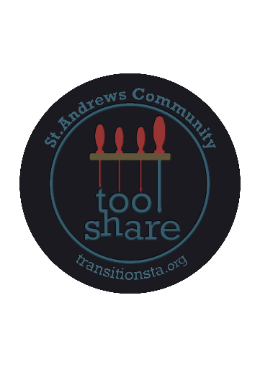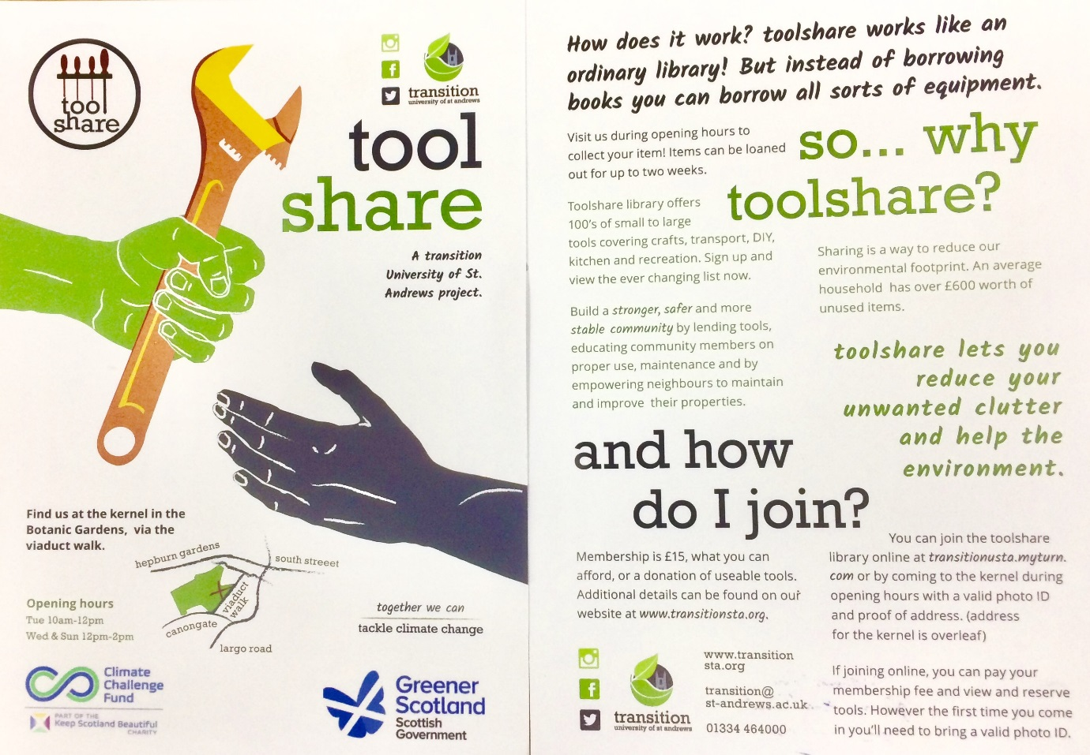
Thirdly, beer mats were designed, printed and distributed to local pubs and restaurants and fourthly a Face Book page was set up where new tools, donations and tool demonstrations linked in with Skill Share were posted. Face Book has been especially effective in engaging local interests and this, in turn, has led to a steep increase in tool loans and awareness in a positive feedback loop. In collaboration with Skills Share, Tool Share now run weekly courses for folk to learn new skills with a variety of tools, such as making wooden signs using a router or making wooden spoons or spatulas using a jig saw and a Dremel multi-tool. People who sign up are given an opportunity to make an item from scratch, so they learn new skills and leave at the end with a product that they have made personally. Sessions have also been linked in with Edible Campus such as tool sharpening for residence garden leaders.
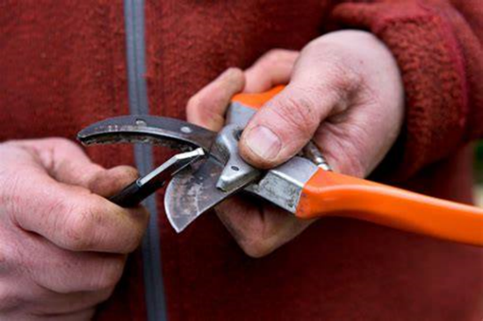

Currently Tool Share has 57 members and 155 Face Book members, with interest growing daily. Items loaned out between 1/4/18 and 31/3/19 in terms of loan frequency can be seen in Table 1 below:
Tool item(s) | Loan frequency
Power drill | 16
Dehydrator 1, hand saw | 9
Dremel tool, pyrography kit | 8
25m cable, 15 bit set, engraver | 6
Hand tool set | 5
Power mitre saw, wood carving set, 37 piece bits/socket set | 4
Multi-sander, masonry bit set, circular saw, socket set, corer, jig saw, belt sander, impact driver, impact bit set | 3

Table 1. Loan frequency of various tool items.
Items with two loans included the29 piece bit set, reciprocating saw, reciprocating saw blades, mobile cooler, mobile wash basin, Forge Steel tool kit, jig saw blade set, orbital sander, Guild drill, push mower, slow cooker, Draper hex set, Karcher pressure washer, pallet splitter, litter pick kit, ratchet clamp set, dehydrator 2, flat bit set and mobile shredder. Items with one loan included side cutting pliers, hand plane, maslin pan, claw hammer, screw driver set, electric planer, Dymo letratag, mincer, voltage detector, electric mower, 4m extension cord, induction hob, mobile LED, tote bag, Flymo lawn mower, Bahco hand saw, Erbauer router, router bit set, peg loom and Parkside bit set.
The most popular items loaned were power drills, dehydrators, hand saws, Dremel tool, pyrography kit, 25m extension cable, bit sets, engraver and hand tool sets (Table 1), and this reflects ‘normal’ usage as well as seasonal usage such as food preservation following the harvest. The usage of the Dremel tool and pyrography kit reflects exposure through Skills Share, while engraver use results from labelling newly acquired tools, either from donations or new purchases. The loan of sanders also followed Skills Share courses.
These loan outs therefore showed both regular and seasonal usage. Items such as the power drills, saws, hand tool sets, sanders, bit sets and extension cables were in regular usage, whereas other items showed seasonal use. The Dremel multi-tool, wood carving set, router and pyrography kit were used in Skill Share lunch time demonstrations, while the maslin pan, dehydrators and corer were used during the autumn to make jam, and dried fruit and vegetables. In addition outdoor items like the hand saw, push mower, electric mower and shredder were used in summer and autumn, when grass needed mowing or a garden needed pruning.
Specific loans such as for the Dremel multi-tool increased after a Skill Share demonstration whereby community members were shown how to safely use the tool and it was subsequently loaned out. Skill Share sessions were held to learn how to use the jig saw, Dremel tool and router, where community folk could make a wooden spoon, spatula, or route out a house number or sign on wood. This gave them a sense of achievement in making something themselves out of a piece of scrap wood, which they could take home and use. Feed-back from these sessions also showed that folk enjoyed the experience:
Suzie McArthur, ‘Thanks so much! It was great! What a buzz!’
Gabriella Paterson, ‘Had a fantastic time. Thanks for a fantastic skills share’.
Rhona Watson, ‘Had a great afternoon again thank you for spending time showing us how to use the router’.
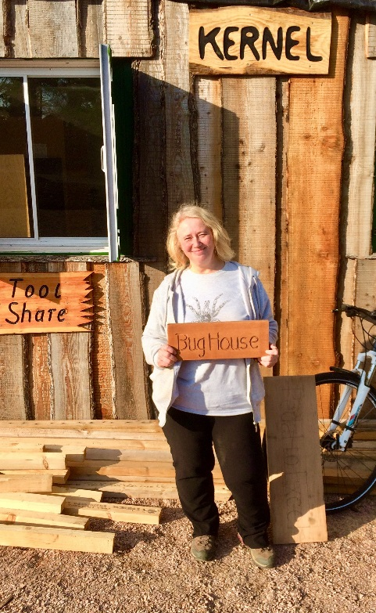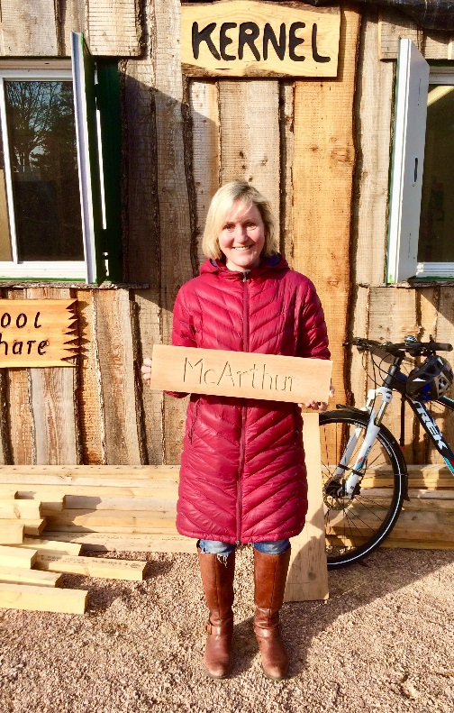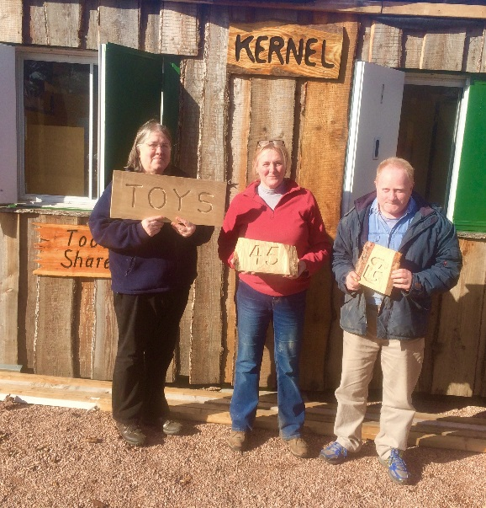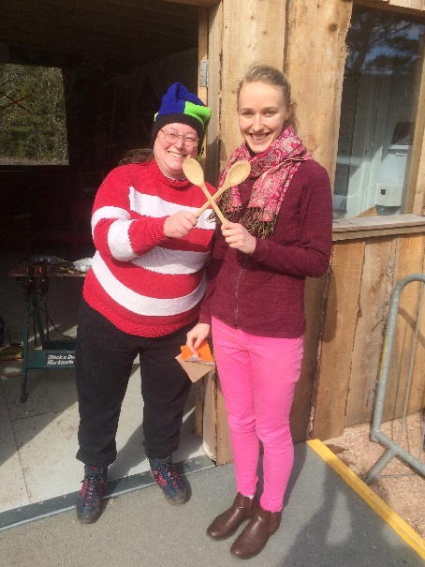
Some happy customers! Permission was given for these images.
Some ‘tool’ items were systems which were specifically purpose made, again in collaboration with Skills Share, like the beach litter pick kit, which included a plastic box containing ten of each litter picks, yellow safety vests and black bag ring. These boxes were then taken out by community and local school groups for beach cleaning activities. Similarly a box containing a dozen plastic plates, knives, forks, spoons, and food containers has also now been made up for community and family picnics. The peg loom kit was also lent out in collaboration with Skills Share.
The tool inventory has grown exponentially during the last year, through purchases of required items from the budget and through donations. Many high priced articles were donated to Tool Share during the year including two electric shredders, an electric mower, hedge trimmer, strimmer, jam maker, band saw, jig saw, hand tools, hand plane, garden hand tools, extension flex and mobile work bench.

A breakdown of tool usage by category showed the following (Table 1 below):
Category | Number loans
Workshop (power) tools | 92
Workshop (hand) tools | 39
Kitchen appliances | 19
Outdoor and Gardening implements | 13
Office equipment | 1

Table 2. Number of loans per category during the period April, 2018 to March, 2019.
Power tools were by far the most popular category of tool borrowed, followed by hand tools, kitchen appliances, Outdoor and Gardening and lastly Office equipment. This probably reflects tool availability (as we only have one office item), but is also reflects that specialised equipment such as dehydrators, reciprocal and mitre saws are now being borrowed instead of being bought, which is the core of Tool Share’s function, to offer a wide range of tools and equipment to the public instead of everyone owning everything and only using it occasionally, if ever.

Fig. 1. Tool use by category.
A total of 160 loans were made over this period covering 937 loan days. The total mass of tools borrowed over the year amounted to a total of 415.7kgs. This translates into 1255kg (1.255 tonnes) of tool carbon saved, which would otherwise have ended up in landfill waste (see Fig 2). The category with the highest carbon saved was garden (594kg loaned over 119 days), followed by workshop tools (562kg loaned over 294 days), then kitchen appliances (140kg loaned over 113 days) and finally office items (5.28kg loaned over 7 days). Although fewer garden implements were loaned out for a total of 119 days, they were heavy, such as the shredders and mowers, so this category had the highest average carbon savings per day (4.99kg; Table 3).

Total Carbon Saved | Workshop (Power & Hand) | Garden | Kitchen | Office
Kg | 562 | 594 | 140 | 5
Loan, weeks | 42 | 17 | 19 | 1
Loan, days | 294 | 119 | 113 | 7
Av Carbon saved/day | 1.91 | 4.99 | 1.23 | 0.75

Table 3. Tool carbon saved per category over the period April, 2018 to March, 2019
Combined workshop items (power and hand) were next averaging 1.9kg per day, but loan patterns were different in that they were made up of many loans taken out more frequently, comprising 80% of the total loans (see pie diagram above). Kitchen appliances were next with an average carbon saving of 1.23kg per day, but this again was due to the loan of regular fairly heavy items such as the two dessicators and maslin pan for preserving and jam making. There was only one office item and this was only loaned out once. However, many of the kitchen items were not used at all, such as coffee makers, blenders and even a Kenwood cheffette, presumably as most people, students included buy their own, or if they do not have, they might try an item such as a slow cooker before buying one for themselves. In this respects it is a bit like the men at Men’s Shed who will not join Tool Share as they all have the tools they will ever need in a shed at home. It is only the unusual or specialised tool or appliance that is loaned out, such as a dessicator or power mitre saw, often for a project at home such as a DIY kitchen refit.

Fig 2. Pie diagram showing total tool carbon saved according to category.

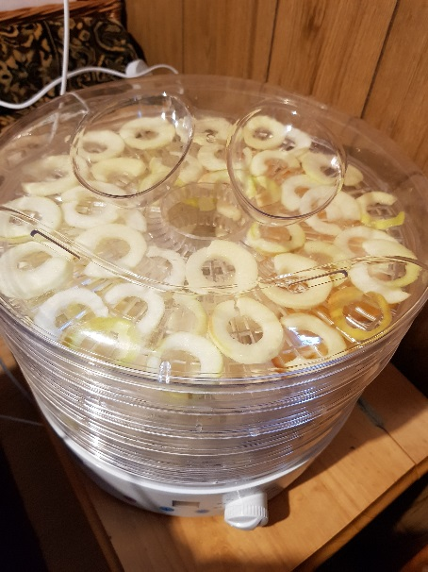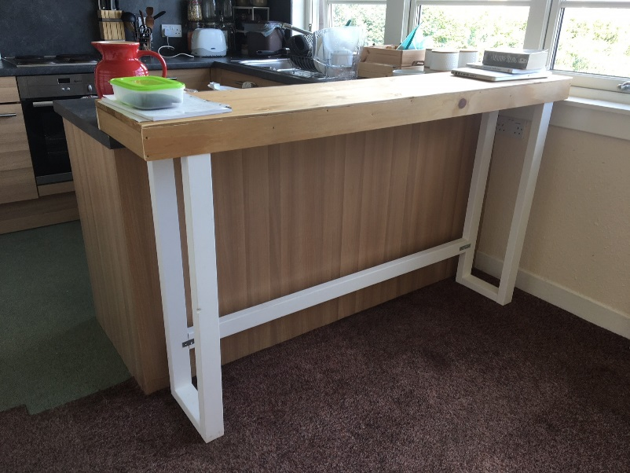
Apple rings in the dehydrator Koert’s DIY kitchen refurb which used Tool Share items
Apart from myself using tools for Transition projects (41 loans) such as making signs for St Andrews Reuse, Tool Share also had regular community customers during the year such as Phillip Scassero (19 loans), Dan Drage (13 loans), Joanna Gibson (10 loans) and Koert Verhagen (8 loans). Phillip, for example was a student volunteer who was working on the revamping of the Observatory garden greenhouse, while Joanna often borrowed tools such as the Dremel multi-tool and wood carving set to make wooden items at home.
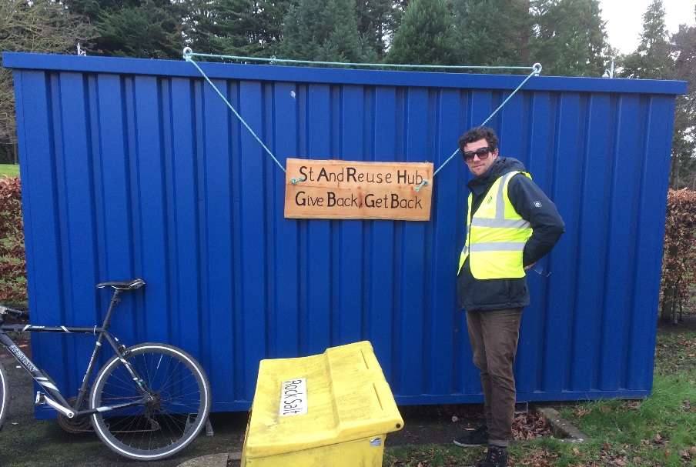
Sam Woolhead posing with the new Reuse sign at David Russel Apartments (DRA).
The range of tools (135 items) has been increased markedly over the last year with 59 new items added, some from the 2019 budget, while most were actually donated by people clearing out sheds and garages and were looking for a good cause to which they could contribute.
In a Google survey, 20 respondents stated that they heard about Tool Share through word of mouth and social media (6), the transition web site (4), University website (2), Freshers Fayre (2), Stumbled on by chance (2), a Transition event (2), posters in and around town (1) and Freshers weekly guide (1). Fifty percent of correspondents stated that Social Media was the best way to communicate with people, which was born out in the Tool Share section of the survey. Most Tool Share members in the survey were new (40% less than a month and 20% from 6-9 months), which reflected the exponential growth in new members through social media. When asked why they joined the responses were that they wanted to avoid accumulating stuff, they liked the idea, they did not have to buy them and that it was good value and very handy. Respondents also stated that commonly borrowed tools were power tools (66.7%), followed by hand tools (33.3%) and beach cleaning equipment (33.3%), a perception that roughly followed the in depth analysis (Fig 1).
The year ahead
- Tool Share has definitely grown and expanded over the last year, thanks largely to social media, improved stock range, donations and linkages with Skills Share.
- Both membership and stock range will be expanded on and links with Skill Share strengthened, hopefully extending opening times through volunteer engagement and involvement and running more Tool Skills Share sessions.
- Tool Share could also be expanded to include a repair section with sessions and demonstrations on how to fix things. For example, saw doctors used be quite common on the high street of every village and town, but with our modern throw-away society it is easier and cheaper to toss the old saw and buy a new one, after all, they are cheap enough through mass production; and this is the problem, all those old saws end up in the skip and then into land-fill. Tools for lathes such as chisels are still frequently sharpened and reused, so why not other items? One lady brought in an old solar panel that wasn’t working and asked if we could look at it. All that was wrong was the terminals needed to be re-soldered and resealed, so was saved from the skip. Hopefully in the future Tool Share members and volunteers can gain experience in repairing and run fix-it-yourself sessions for various items from old furniture or crockery to leatherwear. Tool Share in Stirling, for example, already have a section for both repairs and resale of donated refurbished items such as vacuum cleaners and small items of furniture, so perhaps St Andrews could expand in this direction in the future, while Edinburgh Tool Share also runs repair workshops.
- As different tool categories showed differing carbon savings, perhaps we could cut back on certain items of kitchenware that are never used and expand on other categories that are, such as large specialised items, such as an electric concrete mixer, which would save huge amounts of carbon with every loan.

Social Media & Publicity Reflection:
Community building and public engagement are at the heart of Transition, so how we reach people is highly important. From the results of an end of year survey, the majority of people heard about Transition either by word of mouth or by social media. And 54.5% think that social media remains the most effective way of communicating to people.
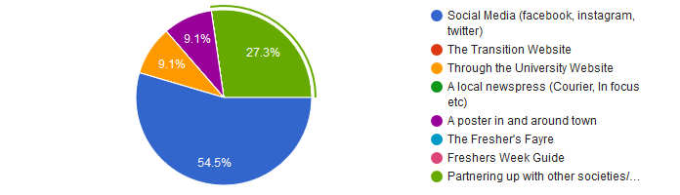
The results parallel reflections the Transition team have had about the importance of a consistent and effective social media presence. In the feedback, one responder highlights the importance of using different avenues for communication to reach different demographics. An opinion that is also shared by 27.3% of people who value the importance of the local news press.
“Depends on the audience - local newspapers good for older community members, social media good for younger community members and students”.
In a multiple other responses, others tell us how partnering with other organisations and societies can be an effective tool for engagement.
“Intensify relationship with university, Schools and societies so that students are more aware of what opportunities there are - especially in their first year!”
“Try and partner with other societies/groups. I know it's really not that easy but being partnered with them, especially on Facebook events, means more people will see what Transition is up to.”
The feedback results point towards a mixture of three avenues for communication: collaboration, printed press and posters, and social media. While these are all things Transition do currently, there is a case to be made for its undervalued significance and pushing these more over the following year.

Report written by
Tansy Torkington, Andrea Roach, Andrea Habeshaw, Winston Emmerson, Sam Woolhead and Alistair Macleod, James Ferns and Kaska Hempel

And also our brilliant consultants/contractors
James Wilson and Judy McGreal at Cyclpath
and
Crispin Hayes at Cripsin Hayes Associates Eco Consultancy

Building a resilient community together
www.transitionsta.org

Part of the

